

**软件测试课程设计报告**

学 号： 20191001171

班级序号： 12

学生姓名： 滕德淋

指导教师： 张剑波

**中国地质大学地理与信息工程学院软件工程系**

**2021年 8 月**

# 一、动态测试技术

## 1. 软件说明

**软件名称：**软件测试-实习一《国航行李计算器》

**程序介绍**：本程序可以根据你携带的行李数量，行李的尺寸和重量，机票以及VIP种类计算托运的费用。

**程序说明：**根据老师发的说明文档进行开发，由于中间说明文档存在矛盾且内容庞杂，所以根据自己的理解进行了软件设计。

### 运行环境配置

#### 前端

开发环境：IntelliJ IDEA 2021.2.2专业版

配置node.js

首先下载nodejs安装包：

官网下载地址：<http://nodejs.cn/download/>



然后进行安装，装好之后在终端测试是否安装成功：

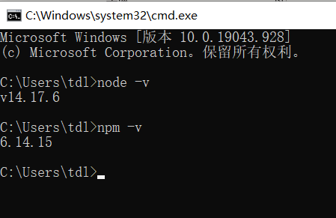

若出现版本号则说明安装成功，之后便可以安装vue框架和vue脚手架了。

官方安装教程：[https://v3.cn.vuejs.org/guide/installation.html#npm](https://v3.cn.vuejs.org/guide/installation.html%23npm)

配置vue，在终端中输入两条指令即可（网上有很多教程，不过都太复杂，原因是因为他们同时教了如何使用cnpm进行安装，建议新手不要尝试）：

npm install vue@next //安装vue

npm install -g @vue/cli //安装vue-cli

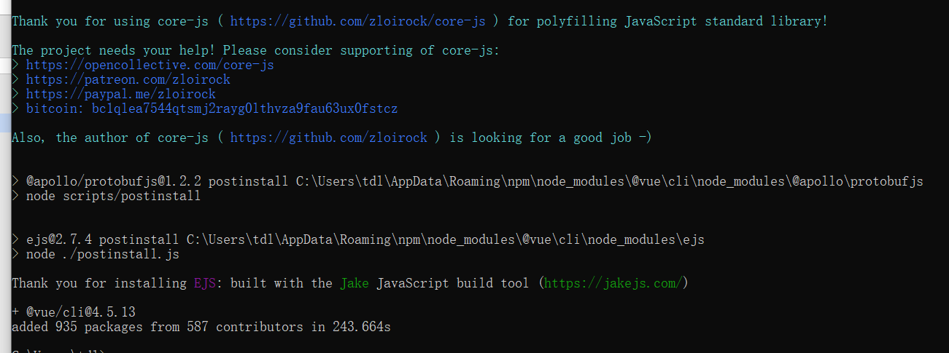

运行完成之后，在终端中测试是否vue安装完成并创建一个初始项目：

终端输入vue指令测试是否安装完成，如果出现如下情况则安装完成

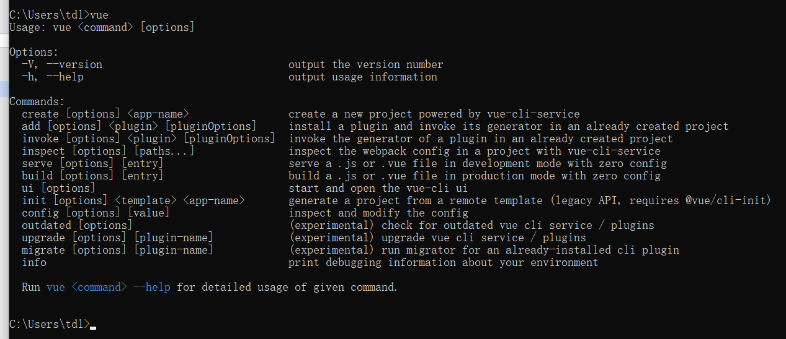

之后便开始用vue-cli创建一个vue单元测试工程：

首先在一个空文件夹下面，打开cmd，然后cd到这个目录下面，输入：

vue create 项目名

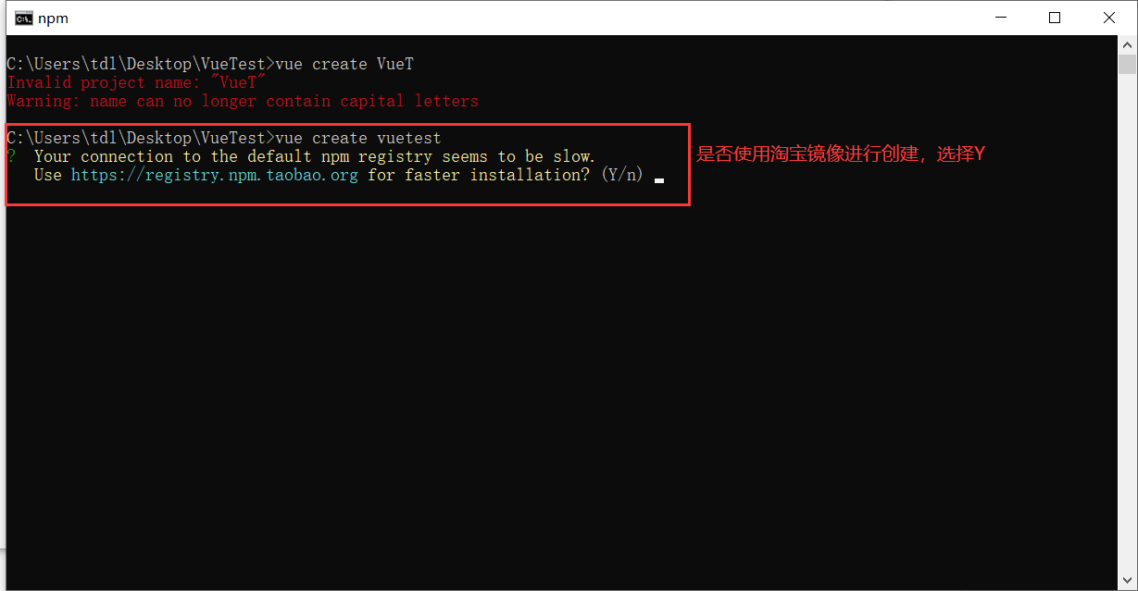

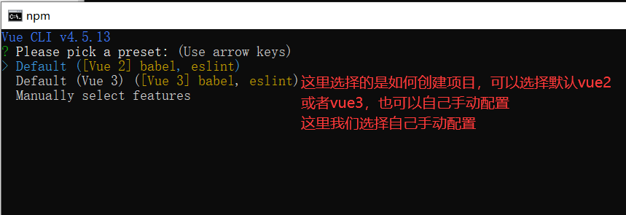

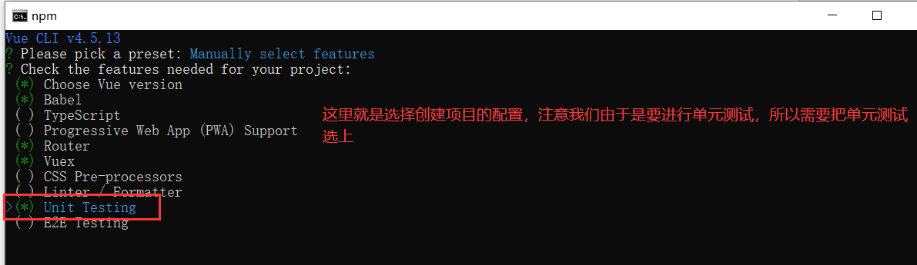

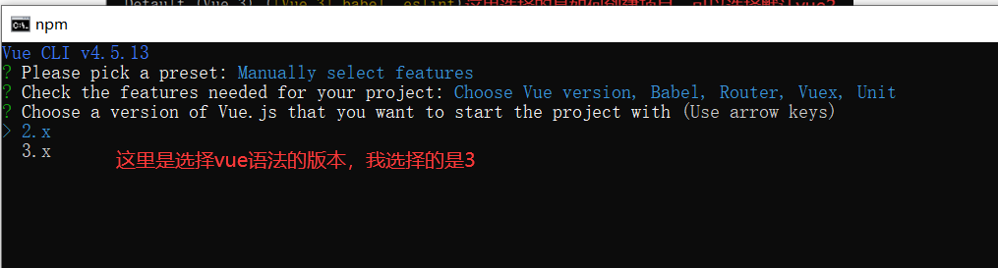

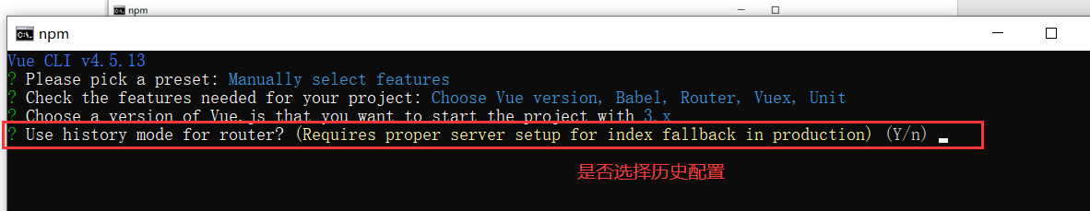

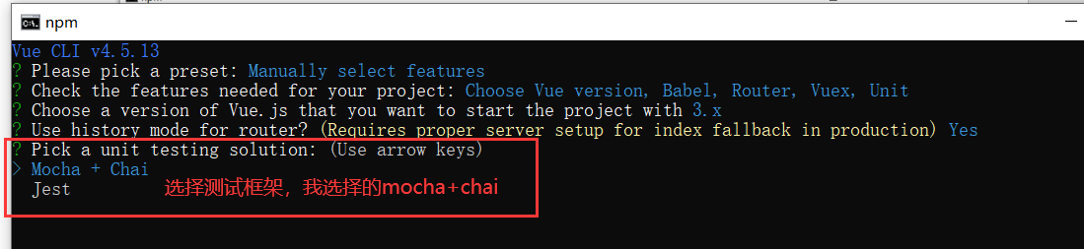

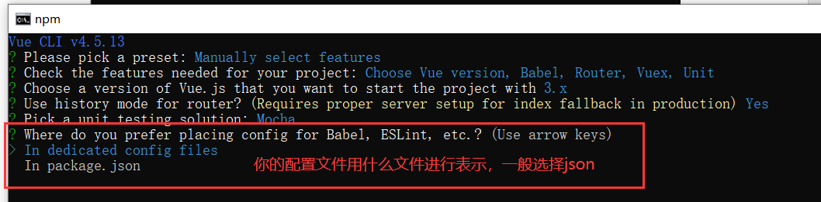

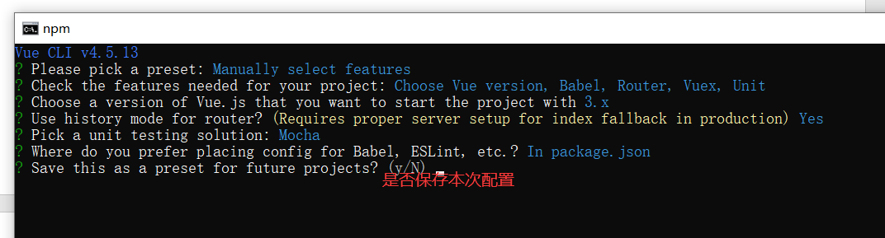

等待一会儿

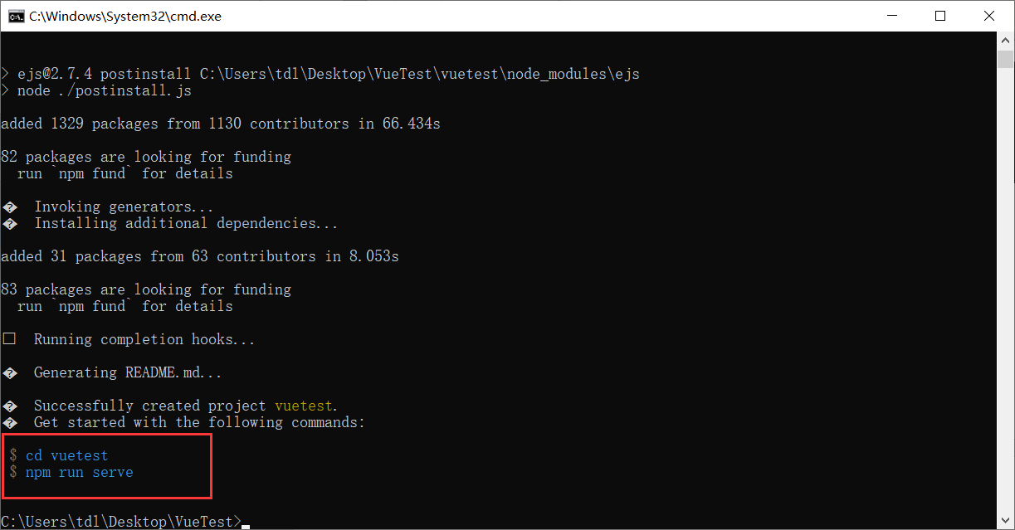

出现上面界面的时候就表示创建项目成功，根据指示，输入上面两行指令运行程序：

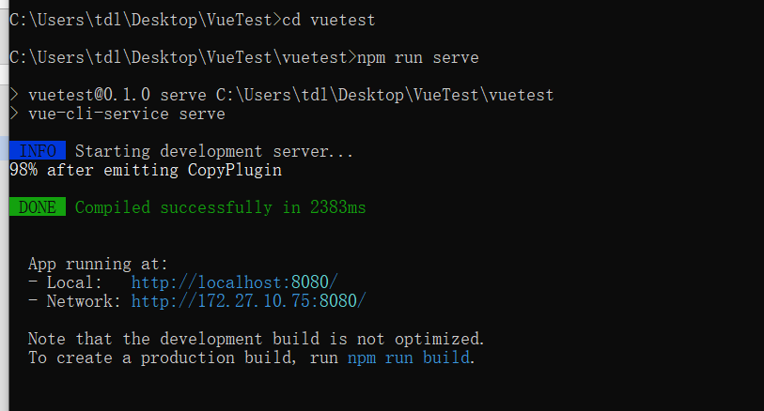

然后打开浏览器输入<http://localhost:8080/>

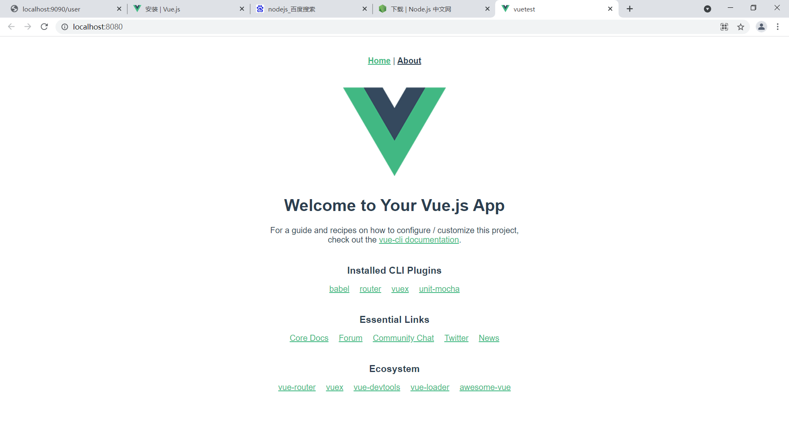

前端开发框架搭建完成。

#### 后端

开发环境：IntelliJ IDEA 2021.2.2专业版

配置springboot

创建一个springboot项目

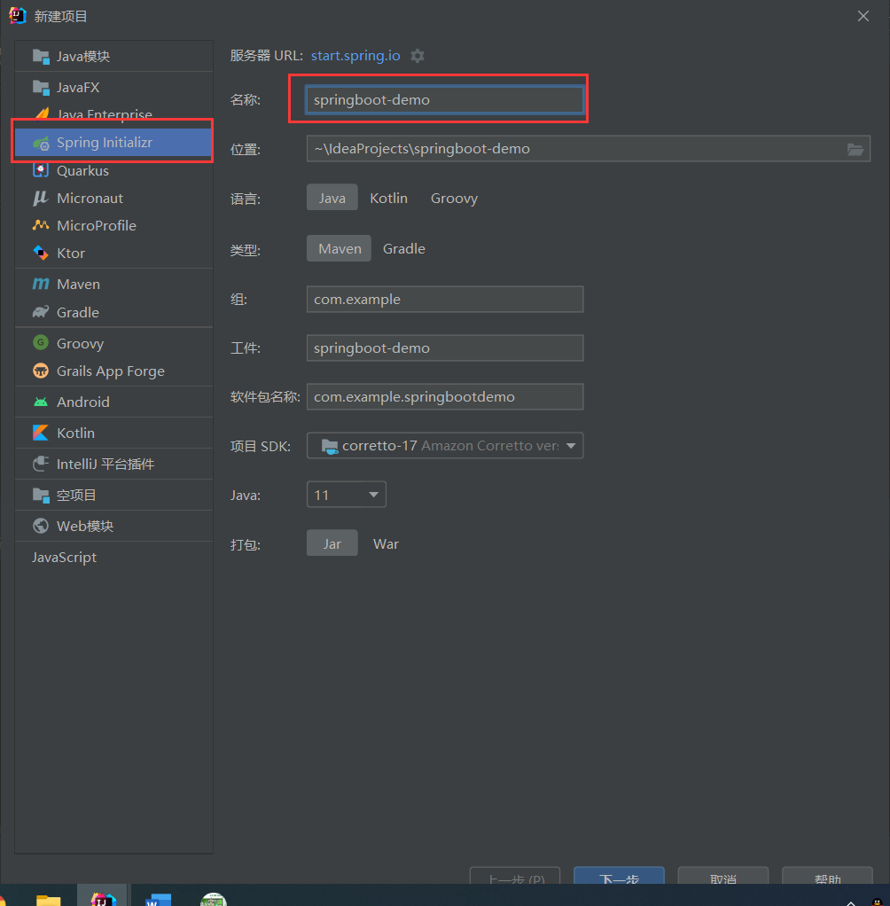

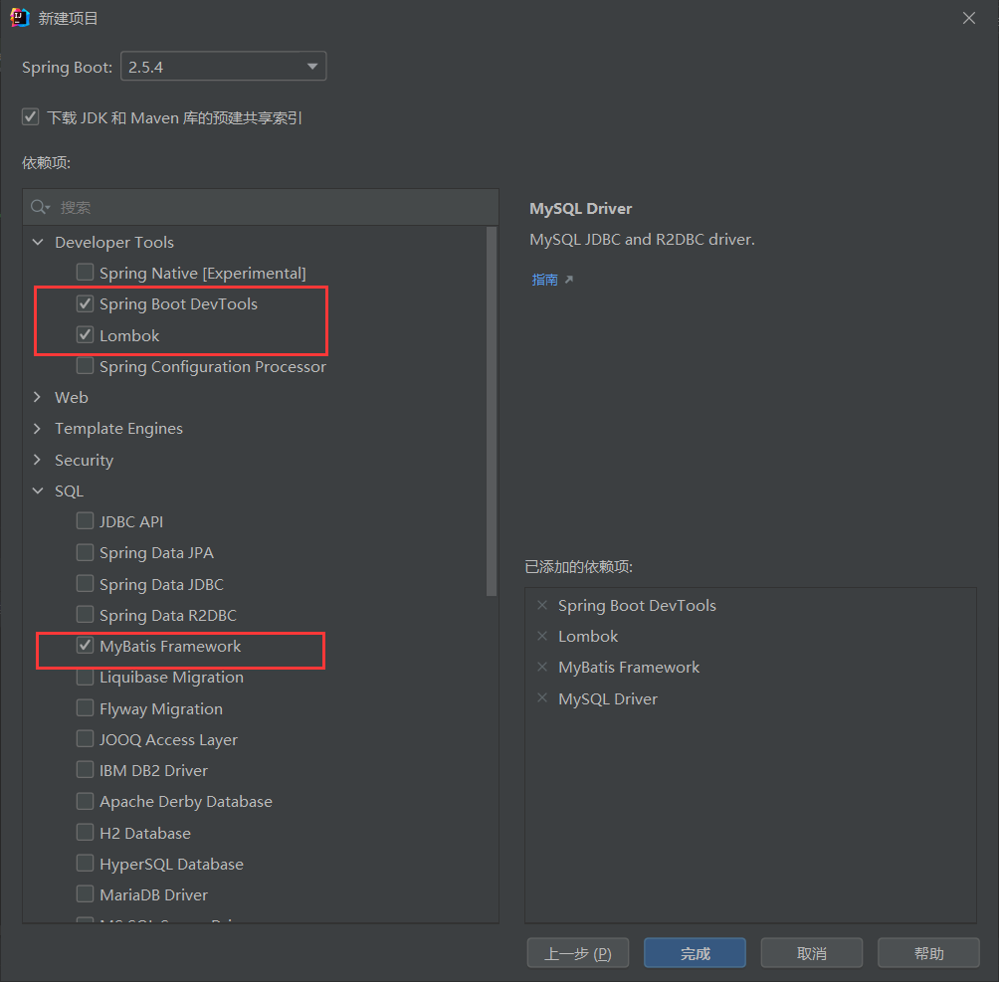

配置maven

1. <dependencies>
2. <dependency>
3. <groupId>org.springframework.boot</groupId>
4. <artifactId>spring-boot-starter-web</artifactId>
5. </dependency>
6. <dependency>
7. <groupId>mysql</groupId>
8. <artifactId>mysql-connector-java</artifactId>
9. <version>5.1.38</version>
10. </dependency>
11. <dependency>
12. <groupId>org.projectlombok</groupId>
13. <artifactId>lombok</artifactId>
14. <version>1.18.2</version>
15. </dependency>
16. <dependency>
17. <groupId>org.springframework.boot</groupId>
18. <artifactId>spring-boot-starter-test</artifactId>
19. <scope>test</scope>
20. </dependency>
21. <dependency>
22. <groupId>com.baomidou</groupId>
23. <artifactId>mybatis-plus-boot-starter</artifactId>
24. <version>3.4.3.1</version>
25. </dependency>
26. <dependency>
27. <groupId>cn.hutool</groupId>
28. <artifactId>hutool-all</artifactId>
29. <version>5.7.3</version>
30. </dependency>
31. </dependencies>

由于后端我自己使用了数据库，所以我引入了mybatisplus进行配置数据库；

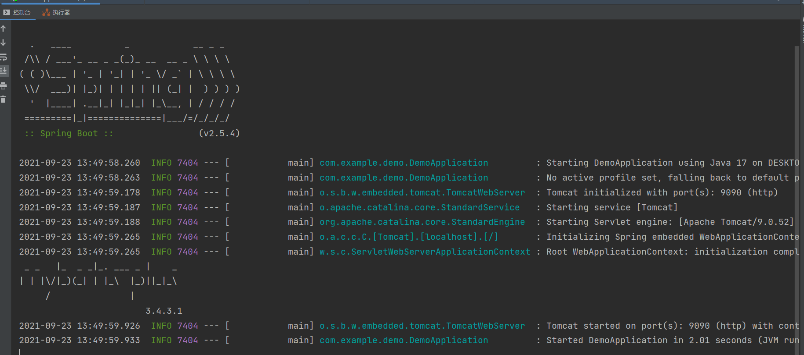

点击运行，出现如上界面运行成功；

### 实现技术

#### 前端技术

采用**Vue**框架，使用**elements-ui**进行界面渲染和数据可视化

elements-ui教程：[https://element.eleme.cn/#/zh-CN/component/installation](https://element.eleme.cn/" \l "/zh-CN/component/installation)

#### 后端技术

采用**springboot**框架，使用**mybatis-plus**对数据库操作

#### 前后端交互

前端交互使用vue的**axios**进行交互，使用8080端口；

后端使用springboot中的**@PostMapping**和**@GetMapping**注解进行交互，使用9090端口；

### 具体开发流程

#### 前端

1. 登录注册（不重要）

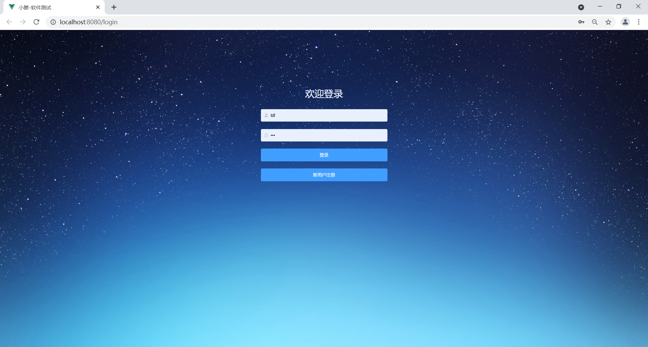

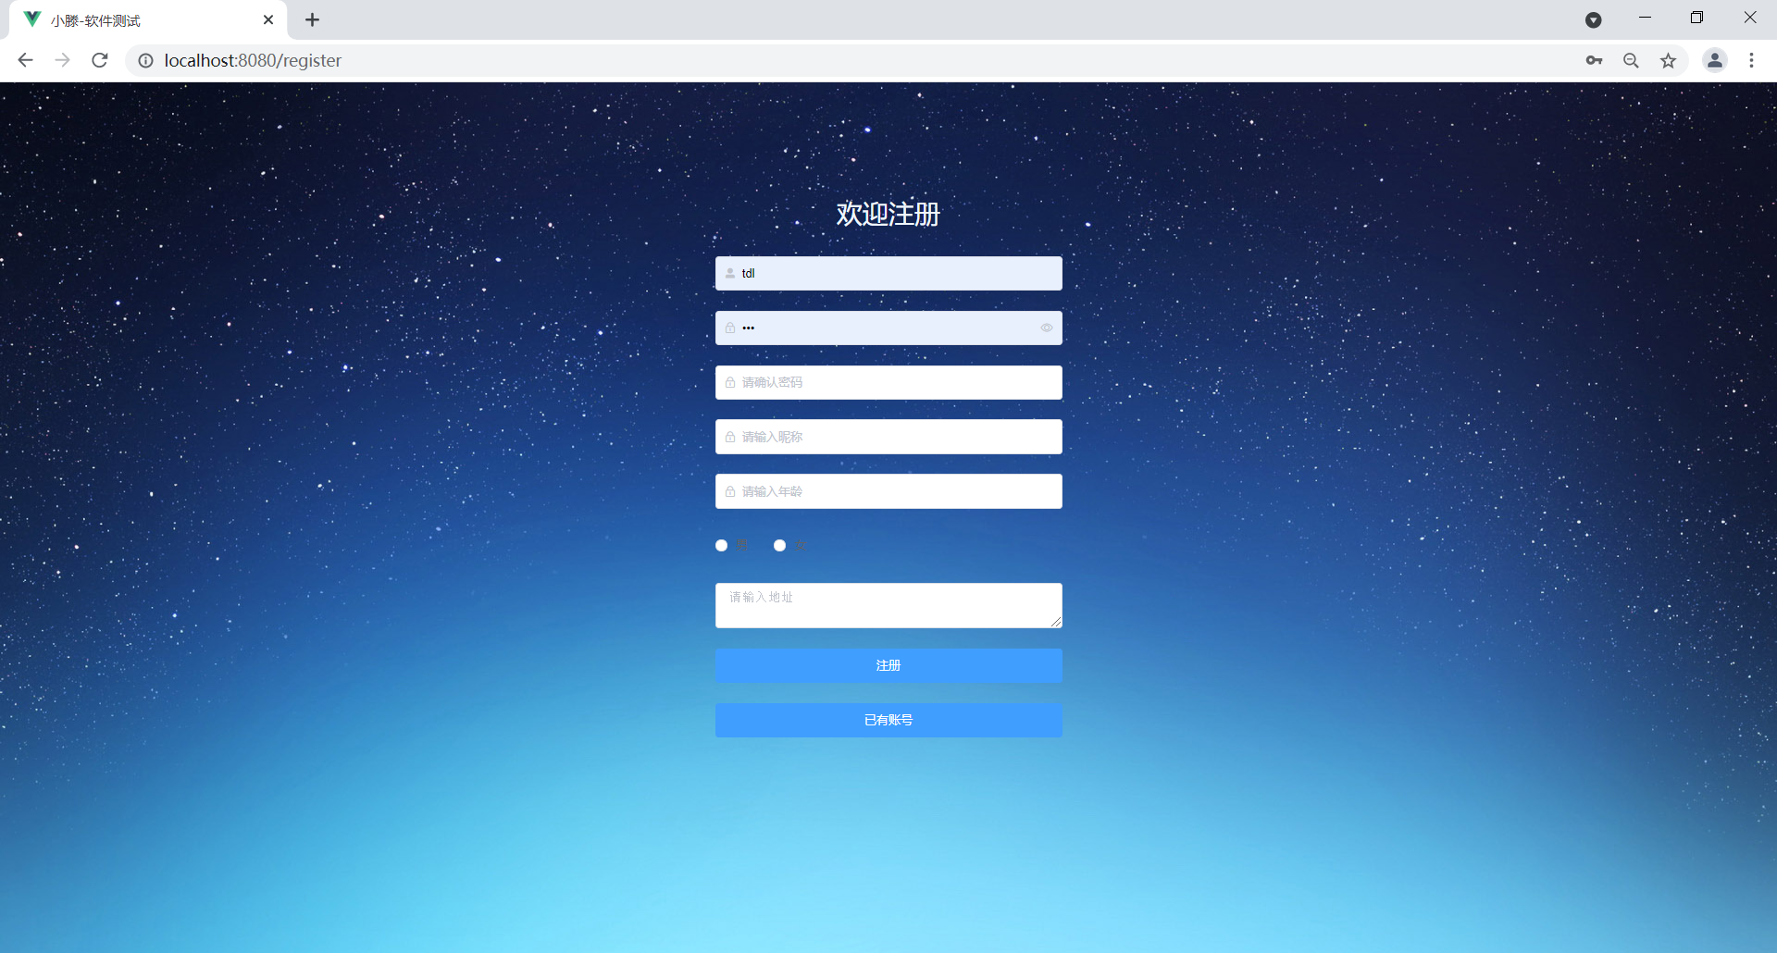

1. 首页用户管理（不重要）

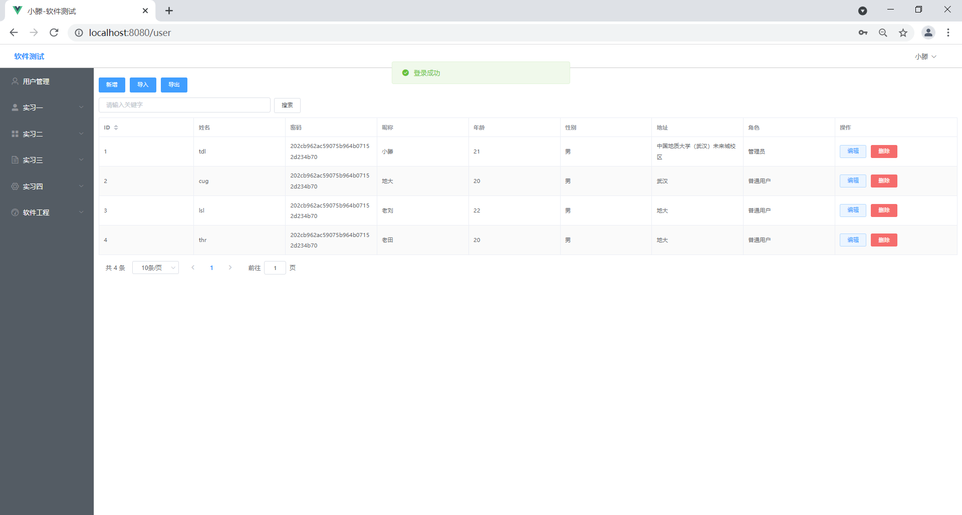

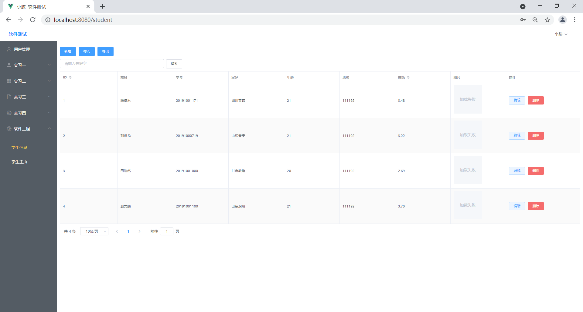

1. **实习一软件（重点）**
2. 界面：

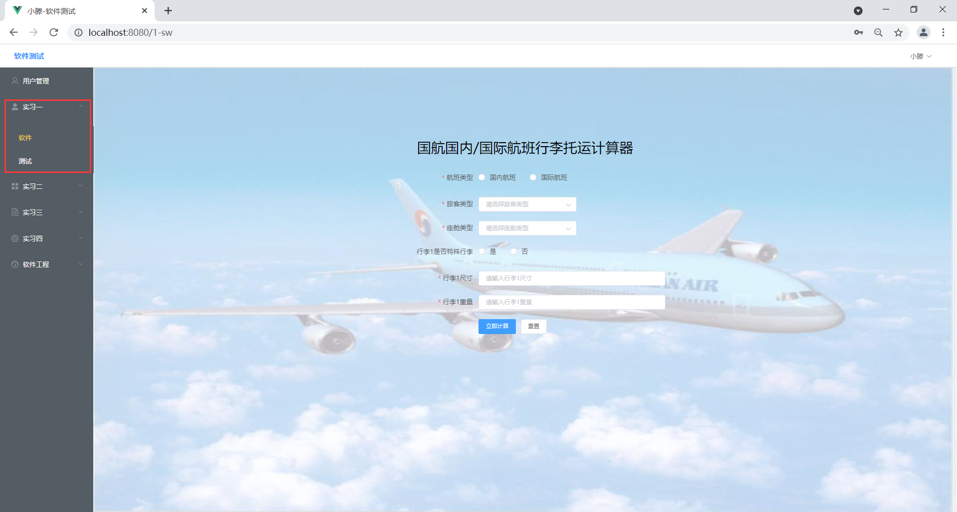

页面分为三个部分：header、aside、conent

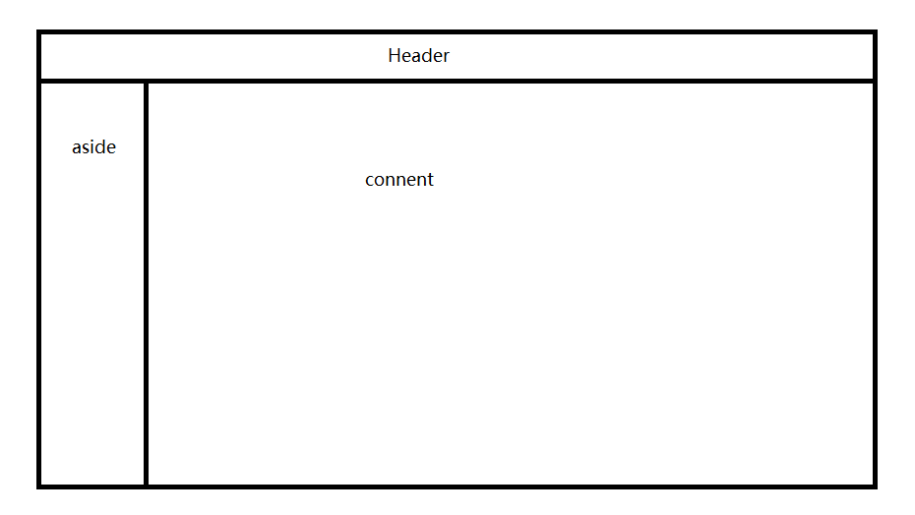

1. Header

由于header在每一个页面都要显示，所以这个部分用一个组件来单独列出来，然后每个文件都引入进去。

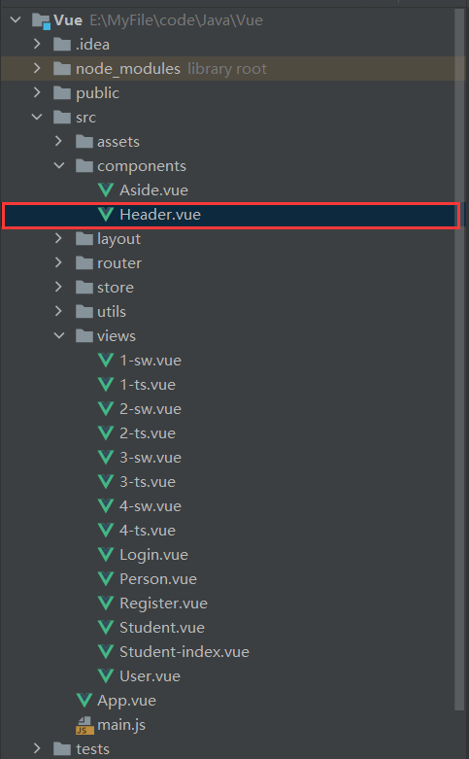

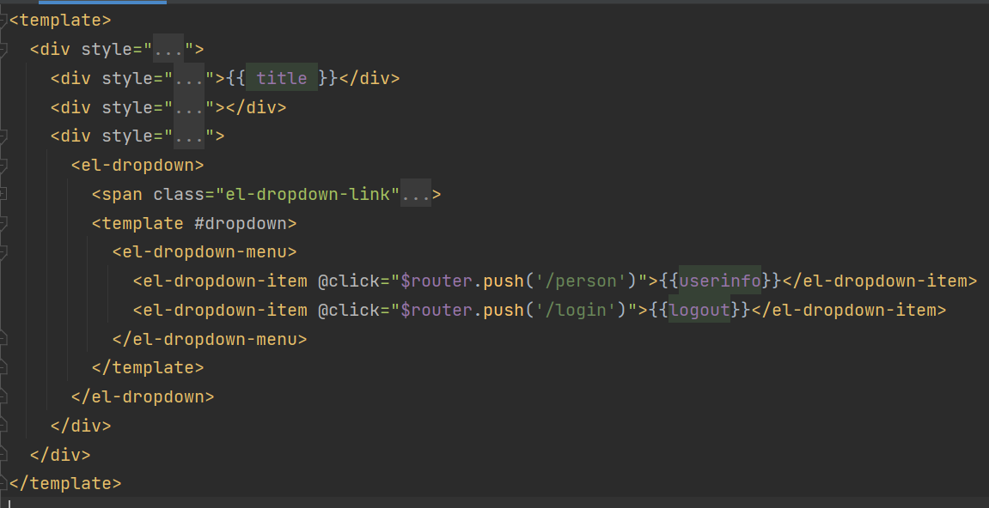

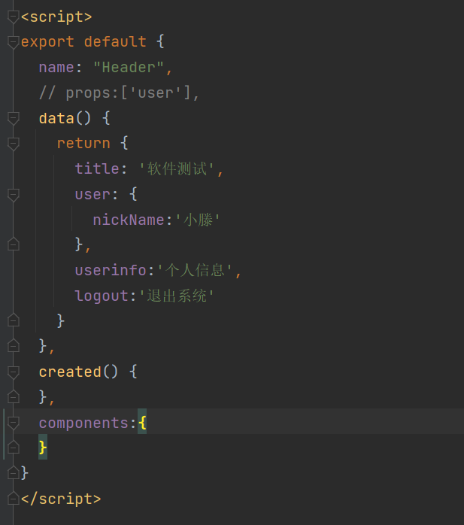

1. Aside

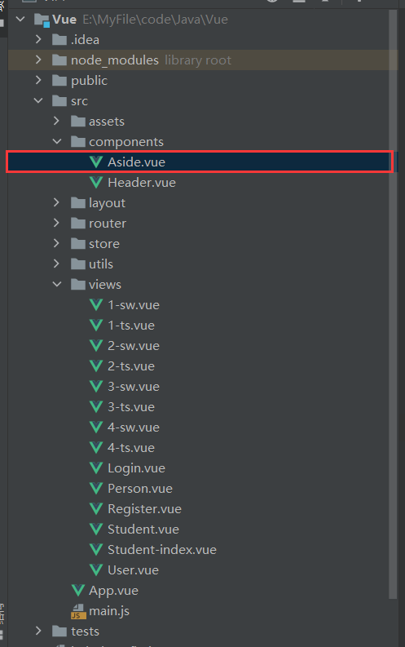

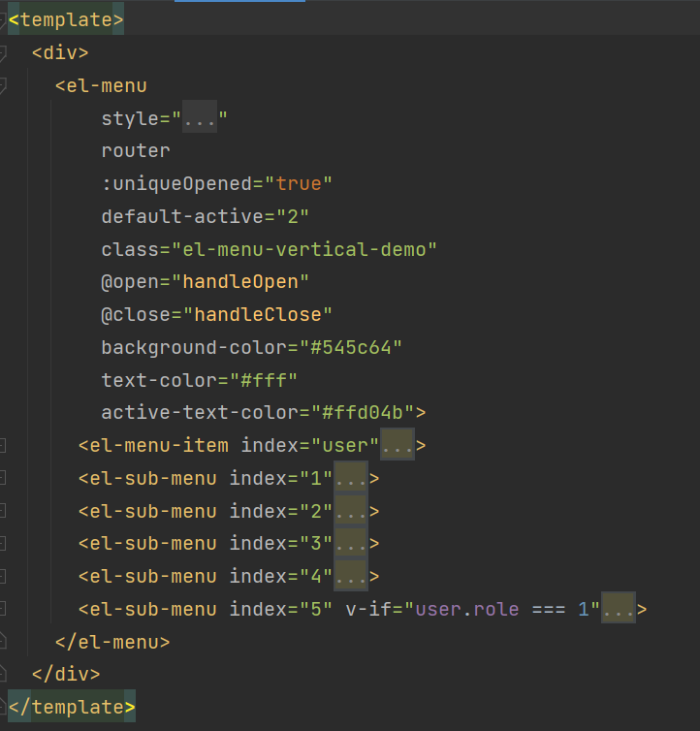

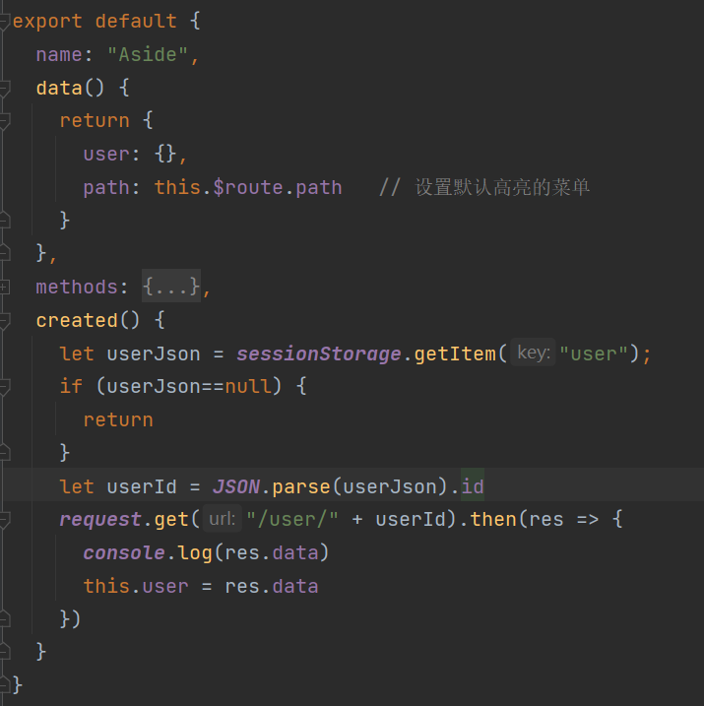

1. Conent

这个地方的界面逻辑比较复杂，因为使用了vue的v-show和v-on等逻辑绑定事件；

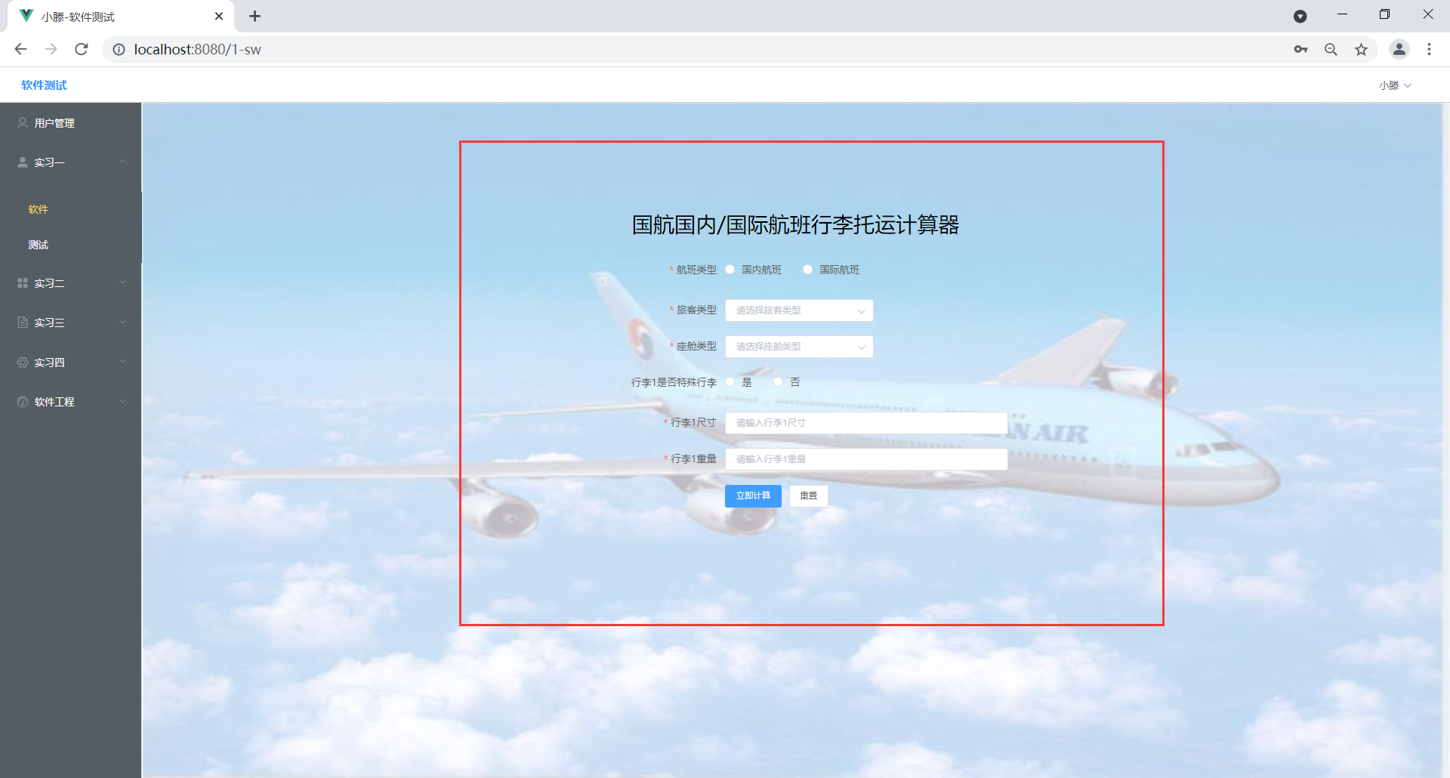



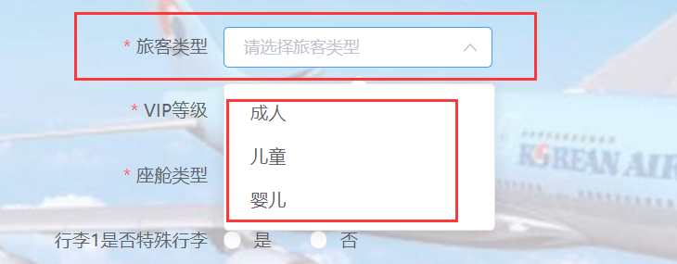

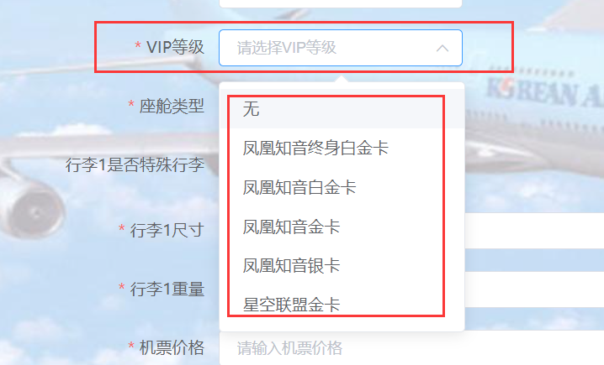

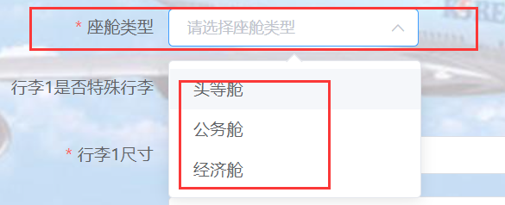









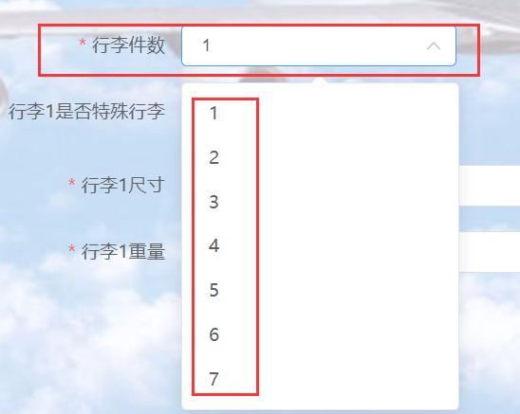

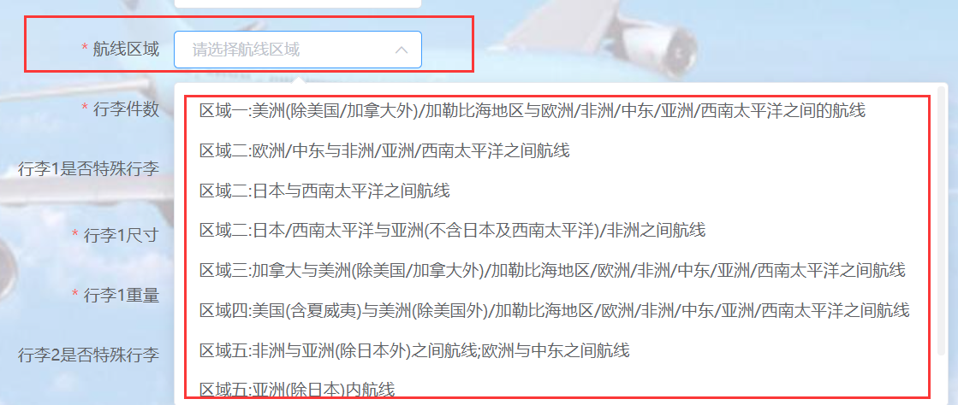

其实这里就是一个表单而已，只是在表单里面有着不同的控件，有单选框、输入框、下拉选择框、提交按钮、重置按钮；

**单选框：**用来选择航班类型和是否特殊行李，然后根据用户选择的不同，下面的输入框情况也会不同，同时传入后端的值也不相同；

**输入框：**用来用户输入行李的尺寸和重量和机票的价格；

**下拉多选框：**用来用户选择行李件数、机票类型等；

**按钮：**用来重置和提交表单；

根据说明文档的要求进行界面的设计，从而方便用户计算，同时也完成计算的输入逻辑；

1. 数据验证
2. 空值

使用vue中的rule验证表单是否为空：

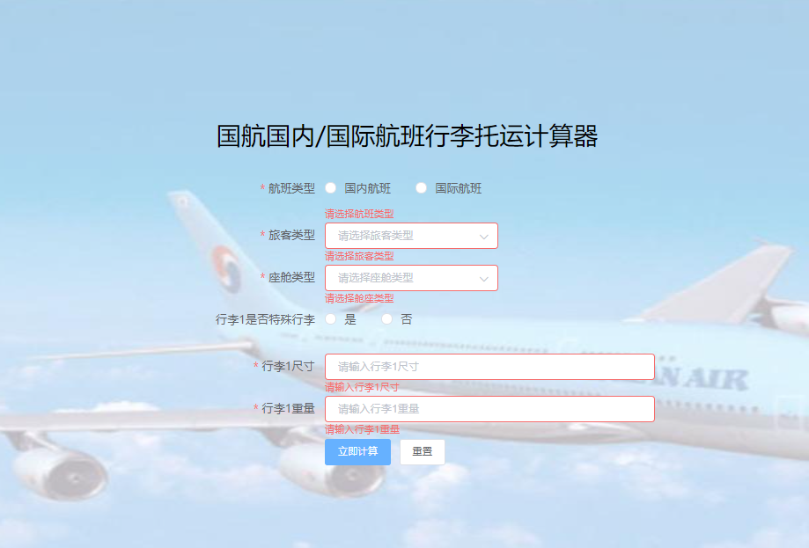

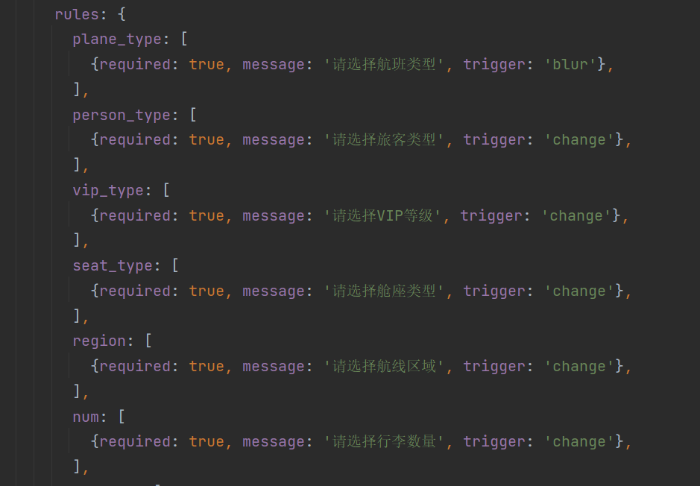

1. 输入异常

当在尺寸和重量输入框内用户输入的值大于5位数，我们认为它是无效的输入，所以在前端就进行阻断。

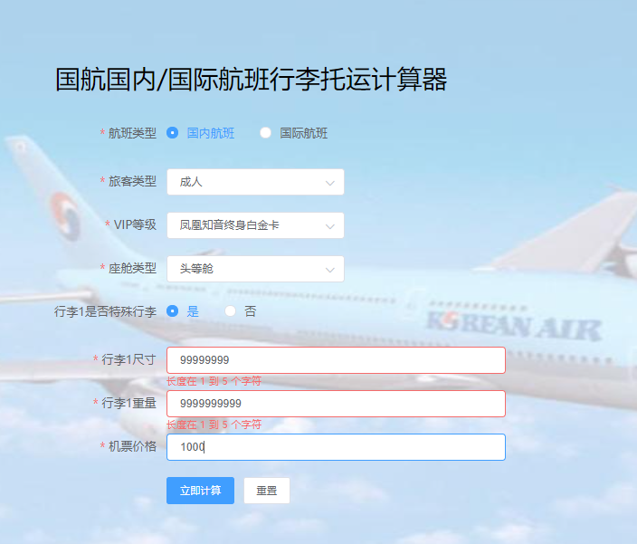

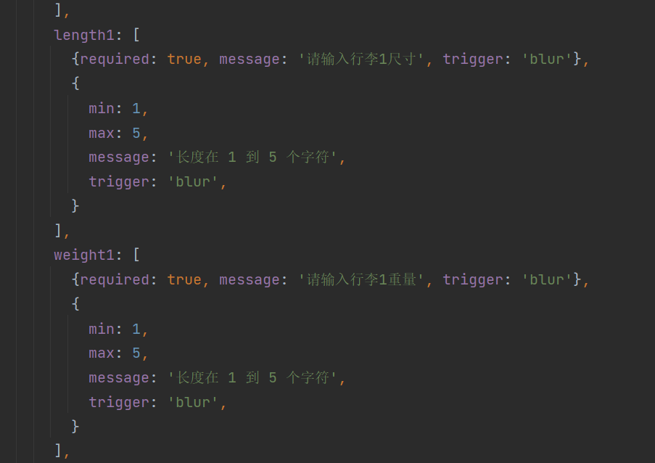

1. 数据交互
2. 发送表单

当填入的数据符合要求之后，点击提交按钮，则会发送一个表单数据到后端，后端如果在运行当中，则会获取数据，进行数据库和计算操作，最后返回计算结果。

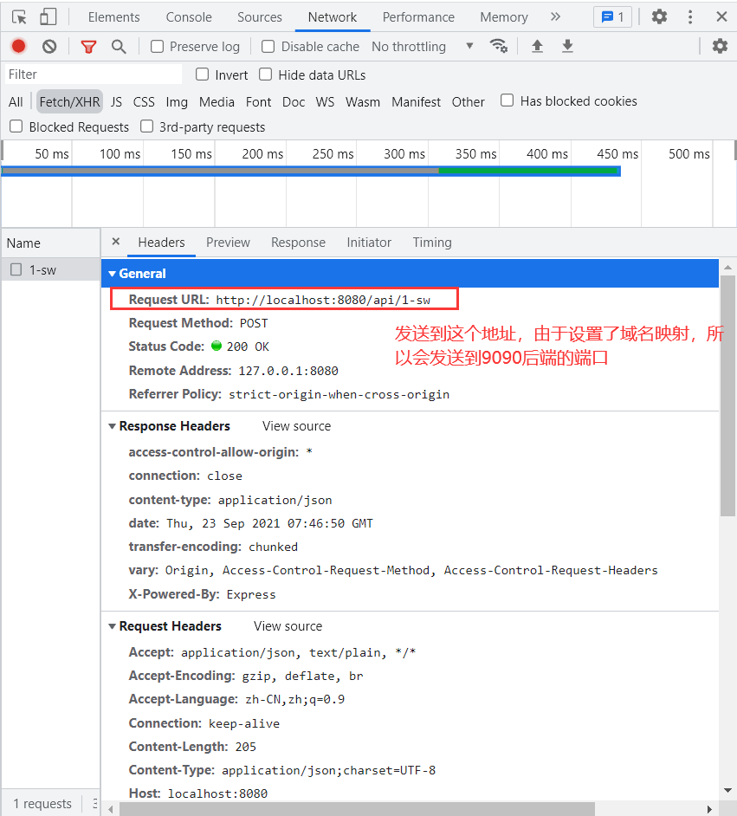

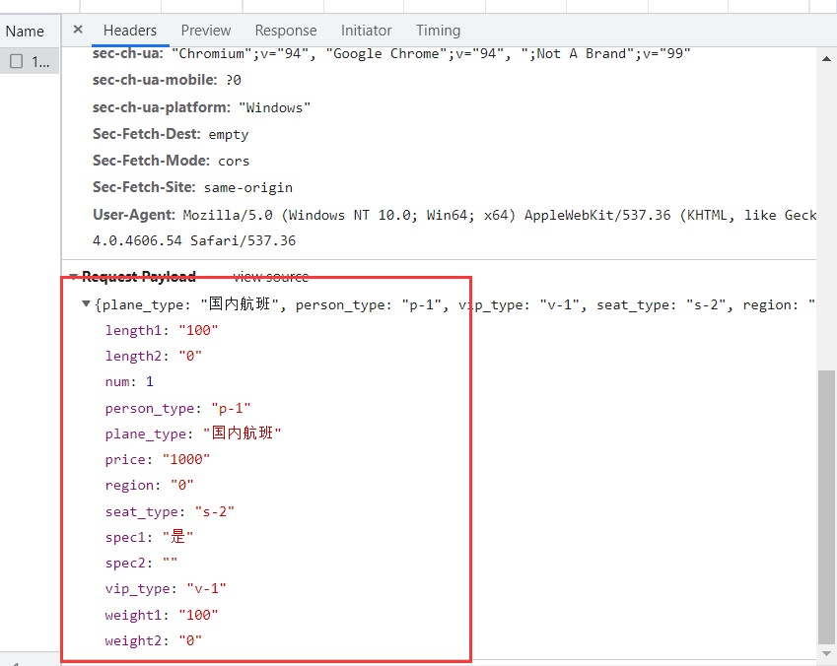

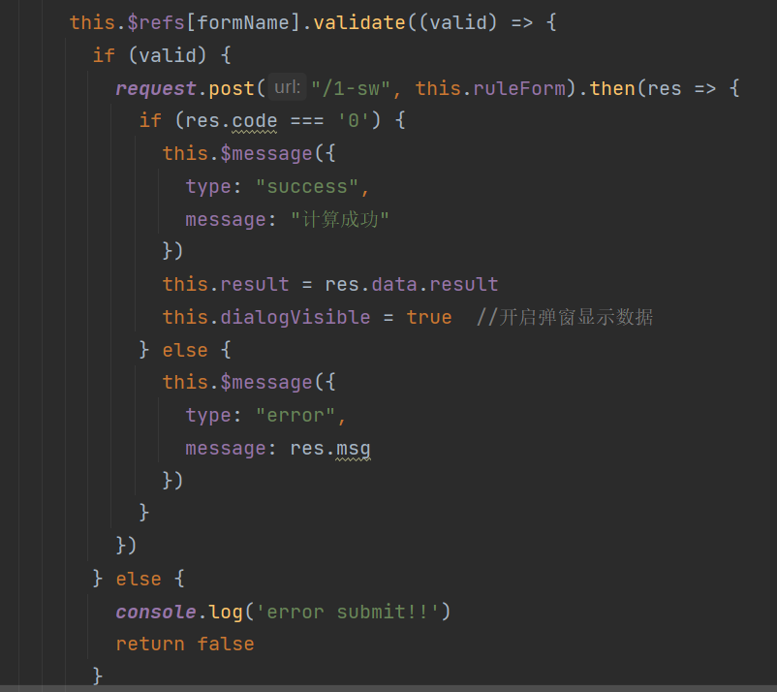

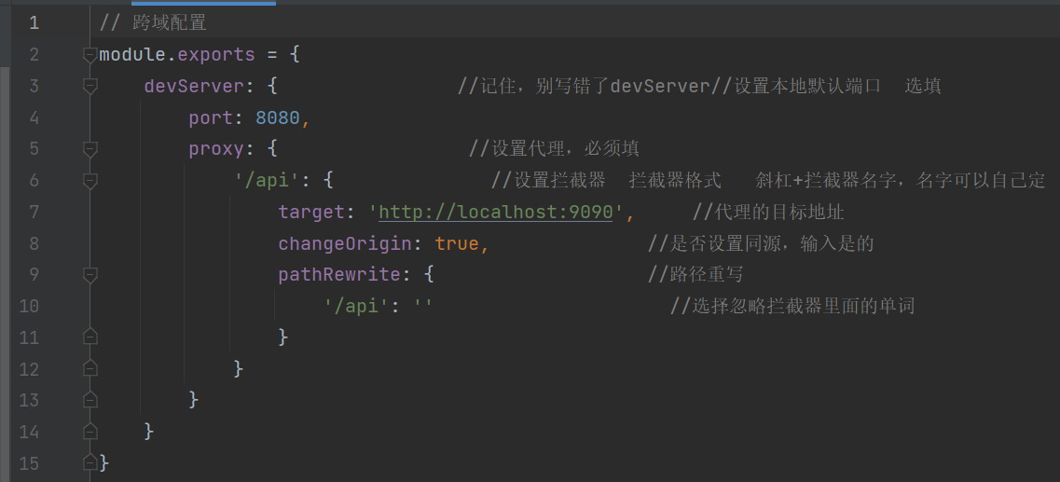

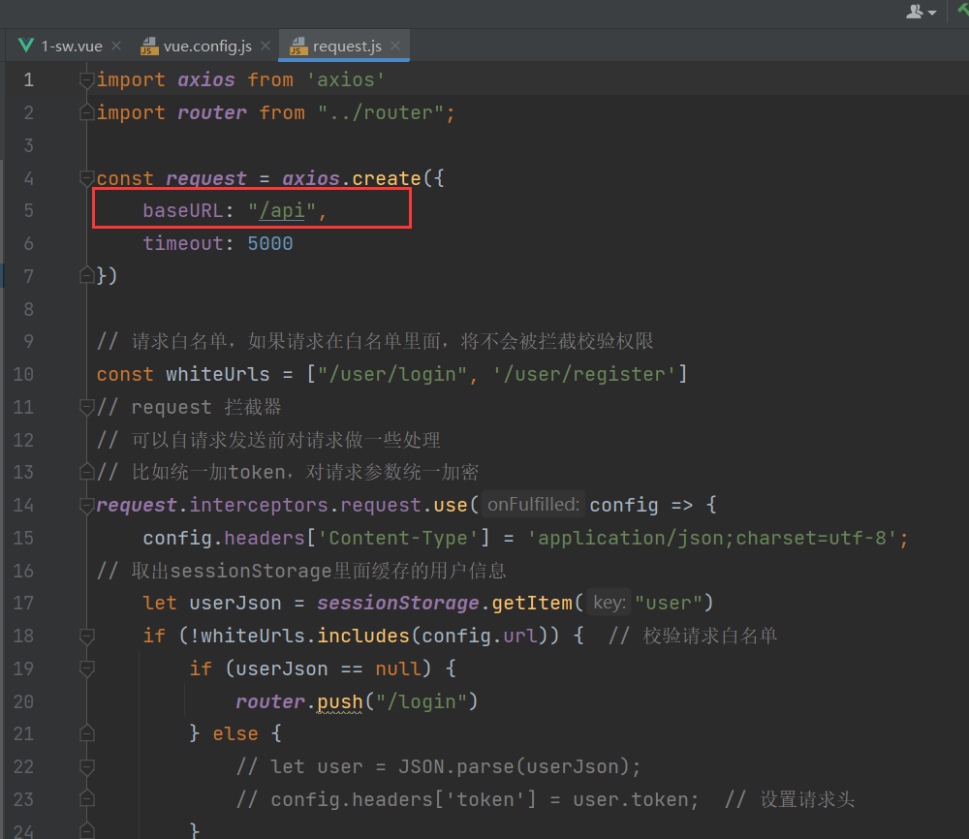

1. 接收返回

后端计算完成之后会返回计算结果，我们在前端接收之后进行显示：

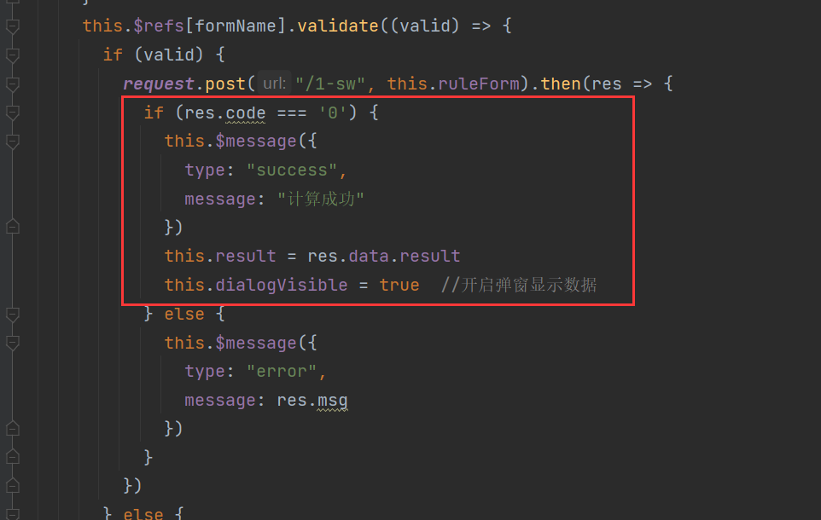

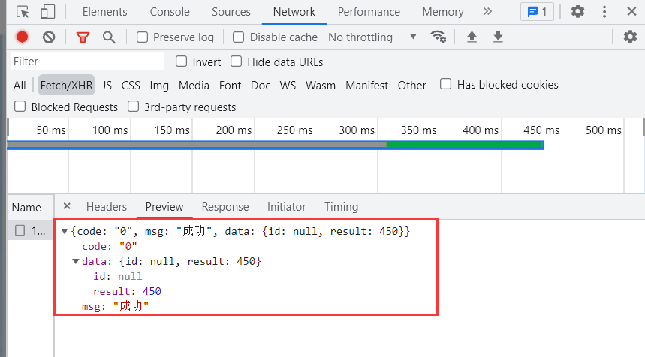

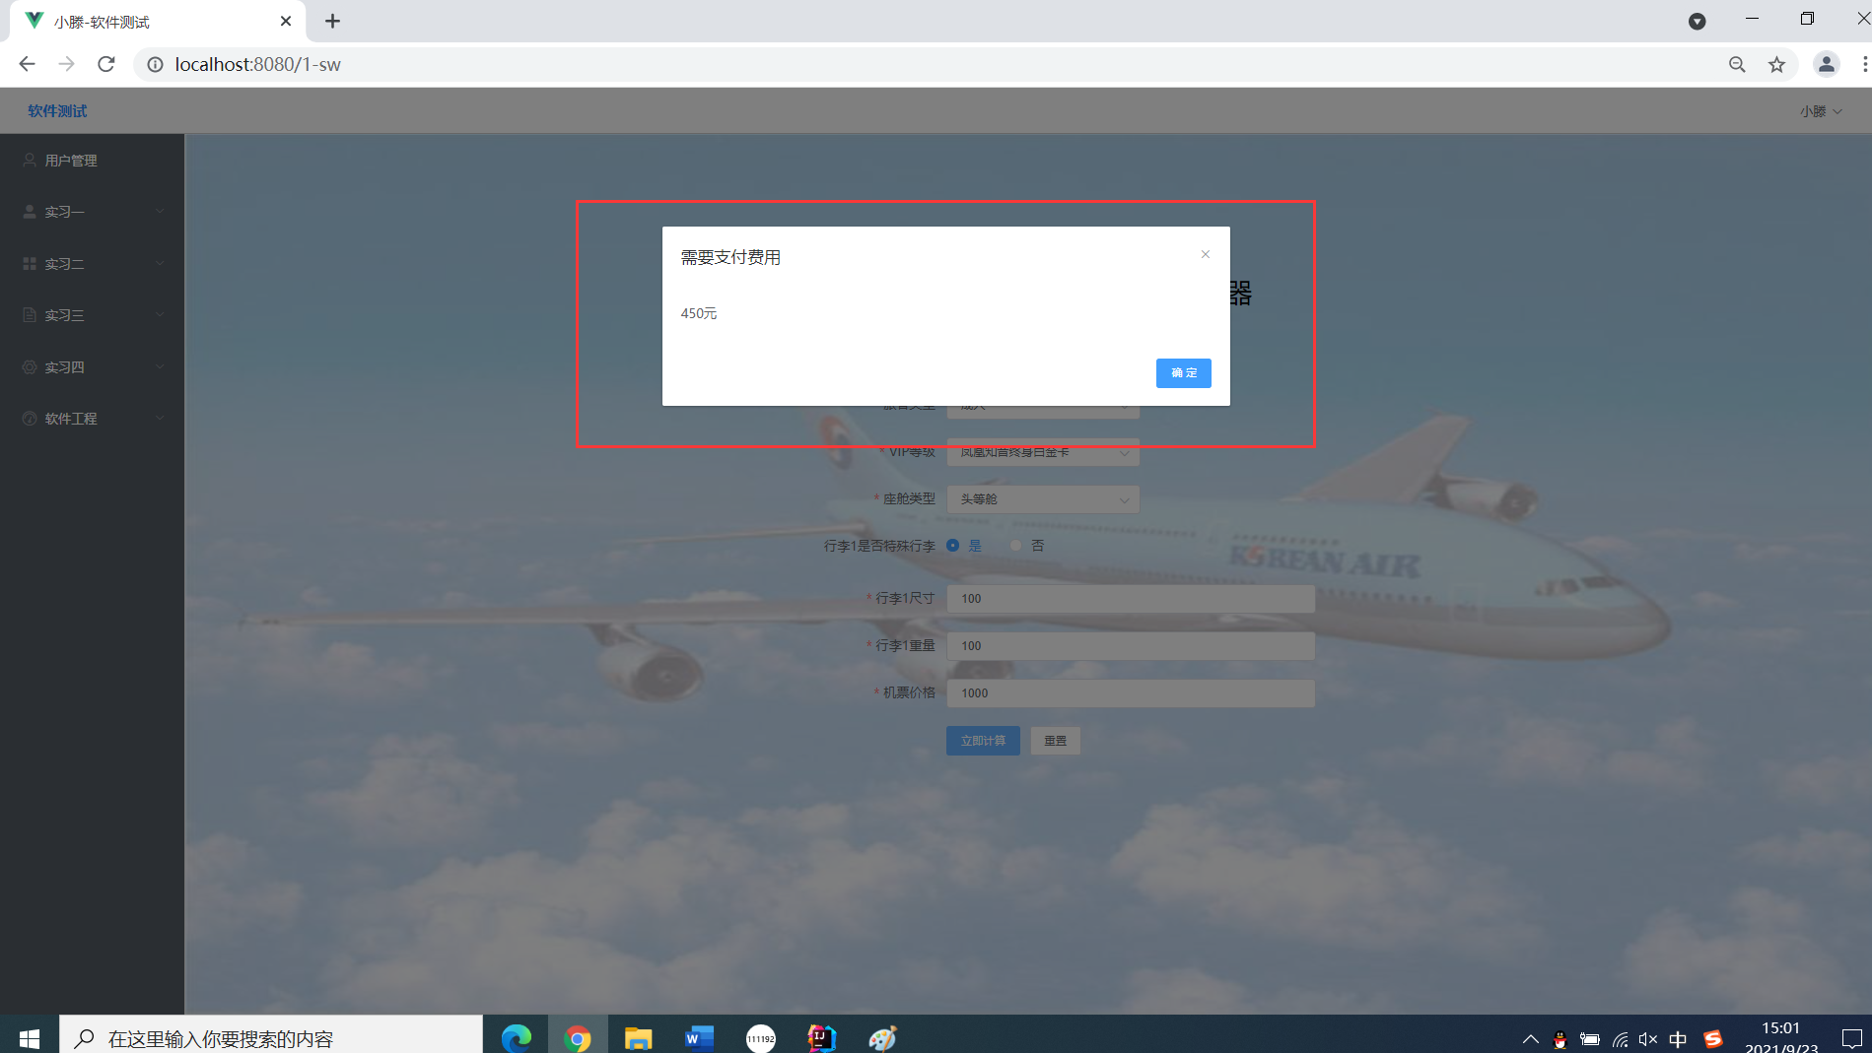

到这里前端界面和前后端交互便完成了，后面会介绍后端怎么进行交互的。其实这里只做了简单粗略的介绍，一些细节方面的东西可能需要很大篇幅来进行解释，但是由于我们这次实习主要是进行测试，所以还是把篇幅留给后面的测试吧。

#### 后端

1. 配置文件
2. server.port=9090
3. file.ip=localhost
4. spring.datasource.driver-class-name=com.mysql.jdbc.Driver
5. spring.datasource.url=jdbc:mysql://8.129.165.170:3306/springboot-vue?serverTimezone=UTC&useUnicode=true&characterEncoding=utf-8
6. spring.datasource.username=springboot-vue
7. spring.datasource.password=123456

主要是端口和数据库的配置。

1. 导入mybatis-plus依赖包
2. <dependency>
3. <groupId>com.baomidou</groupId>
4. <artifactId>mybatis-plus-boot-starter</artifactId>
5. <version>3.4.3.1</version>
6. </dependency>
7. 编写实体类

总共编写了4个实体类，一个是用户信息的实体类，一个是学生的实体类，一个是行李计算器表单的实体类，一个是计算结果的实体类；

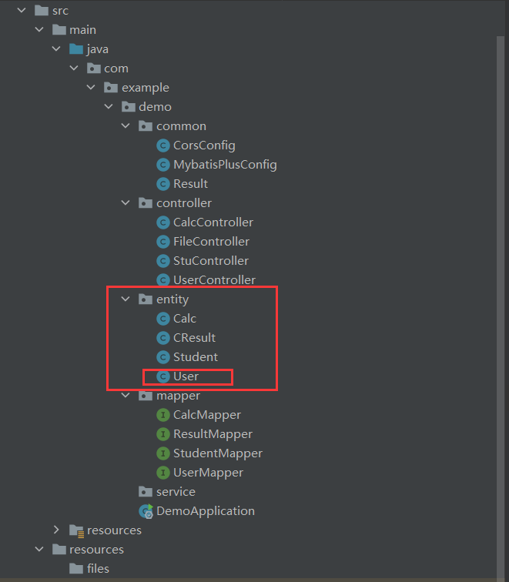

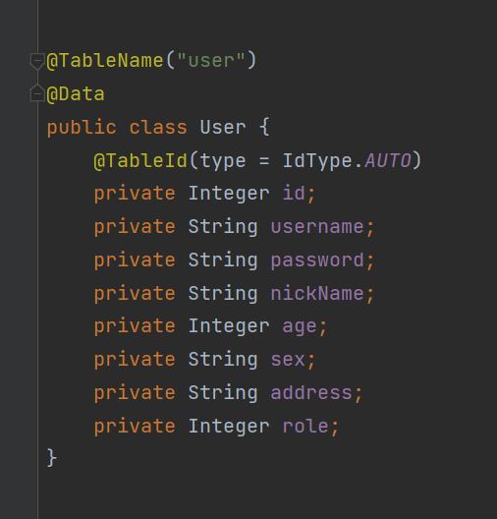

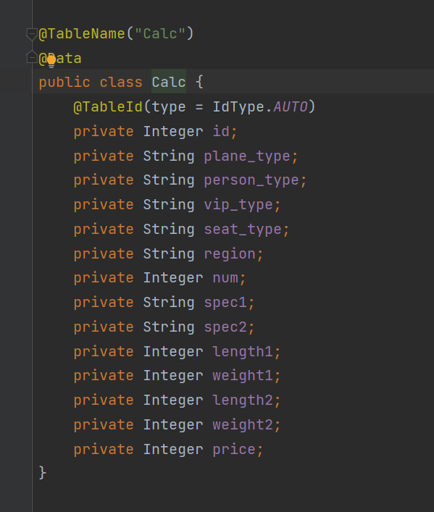

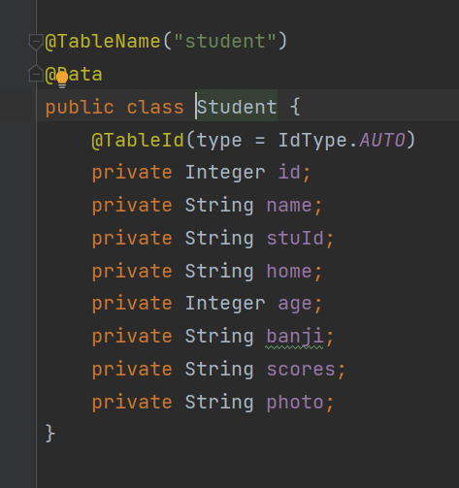

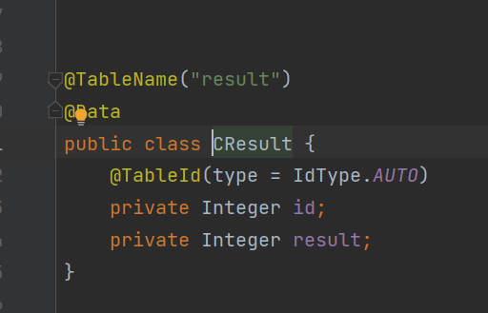

1. 数据库处理

数据库建立：

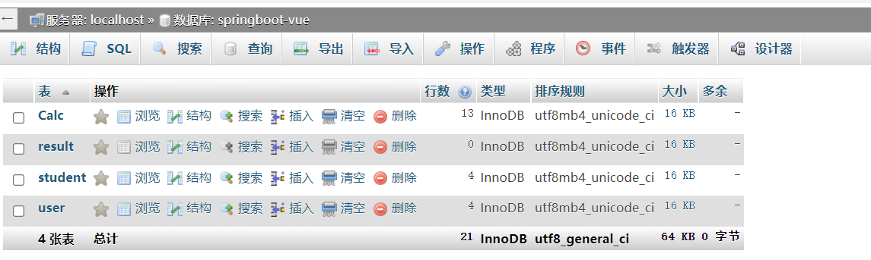

数据库处理：

用户的增删改查：

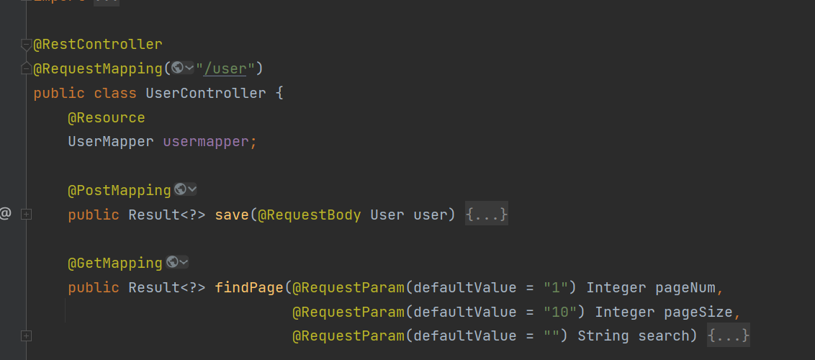

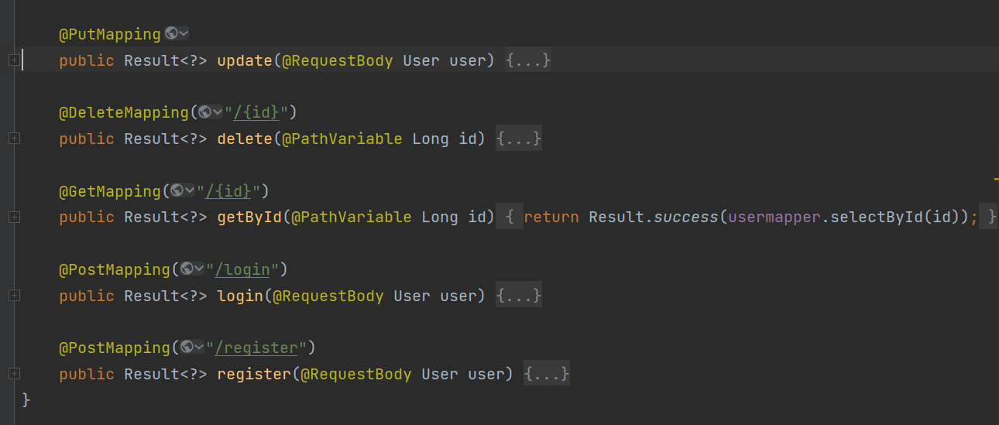

1. 创建行李计算器处理函数

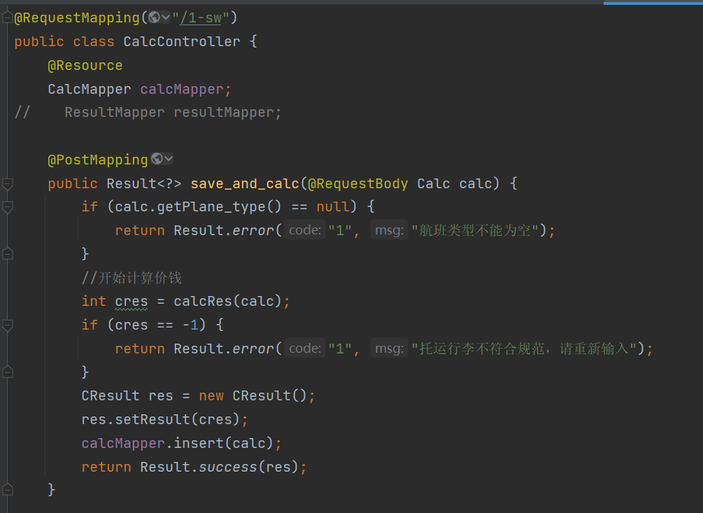

前端经过跨域配置之后，会传送一个表单数据到该目录下，该函数的形参则为表单数据，然后得到所有的信息，进行计算价格（具体怎么计算的，下面讲解）；计算完成之后返回一个Result对象，里面是计算的结果。

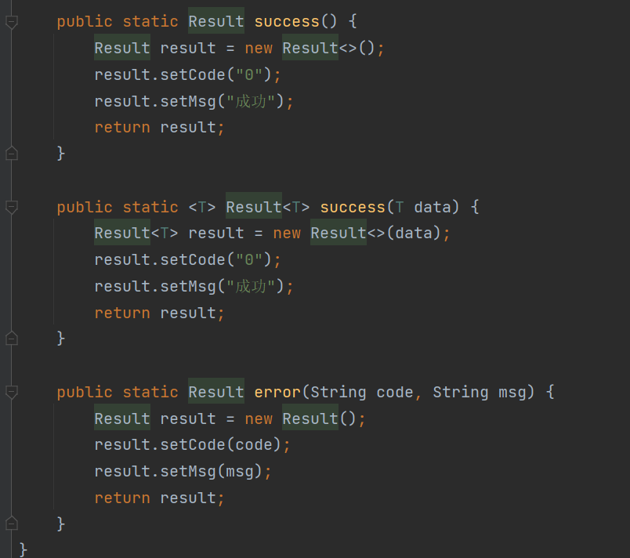

1. 编写行李计算函数

该部分由于属于逻辑代码，不太容易解释清楚，所以在后面的软件功能中进行解释。

### 软件功能

#### 登录注册（非重点）

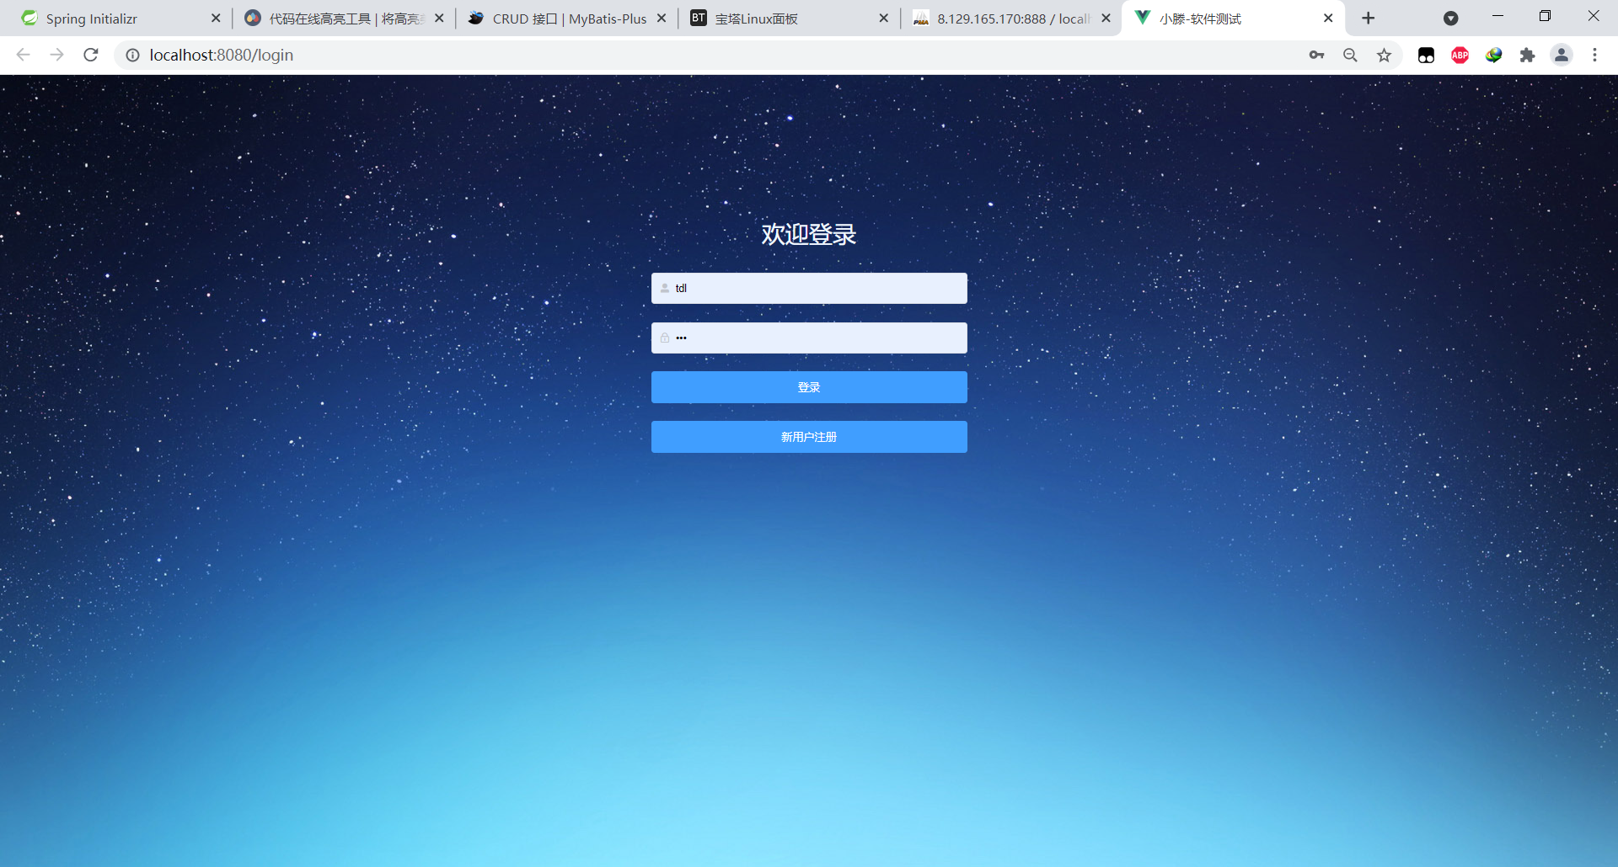

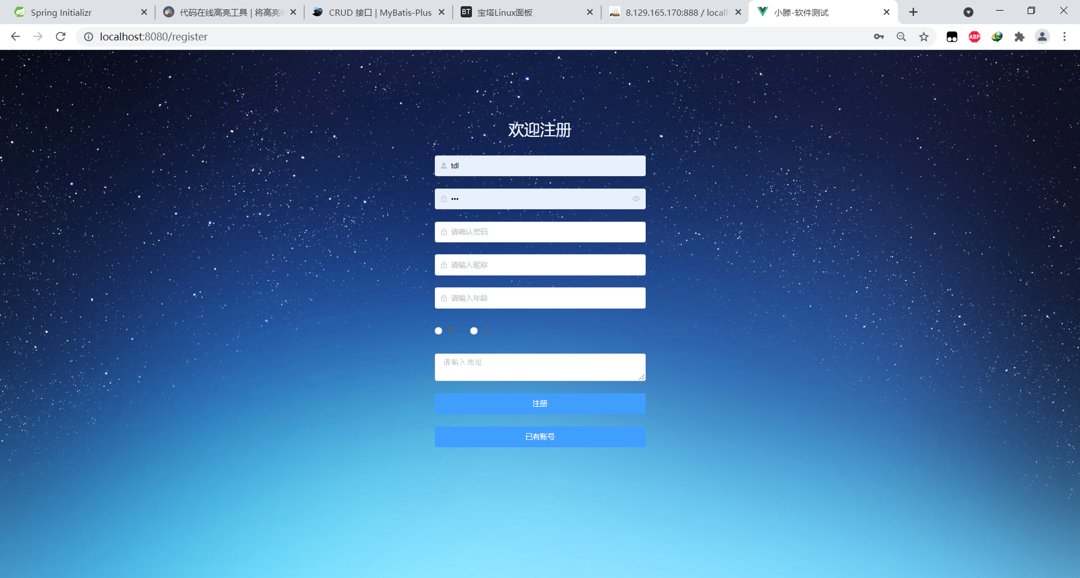

#### 用户管理-增删改查（非重点）

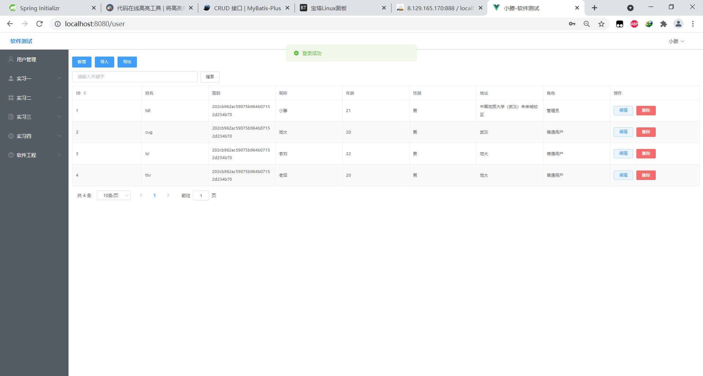

#### 软件工程学生信息（非重点）

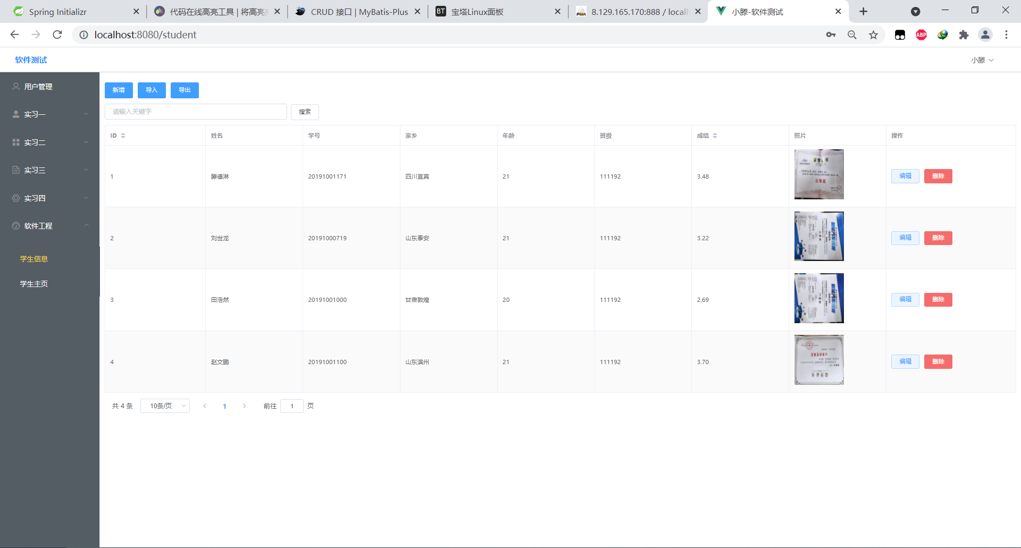

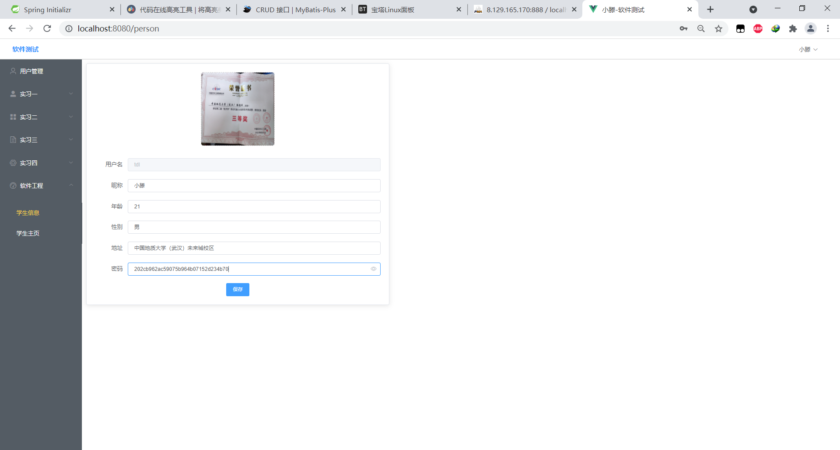

#### 实习一-国航行李计算器（重点）

首先分为国内和国际航班，根据不同的选择，用户输入的信息也不一样；

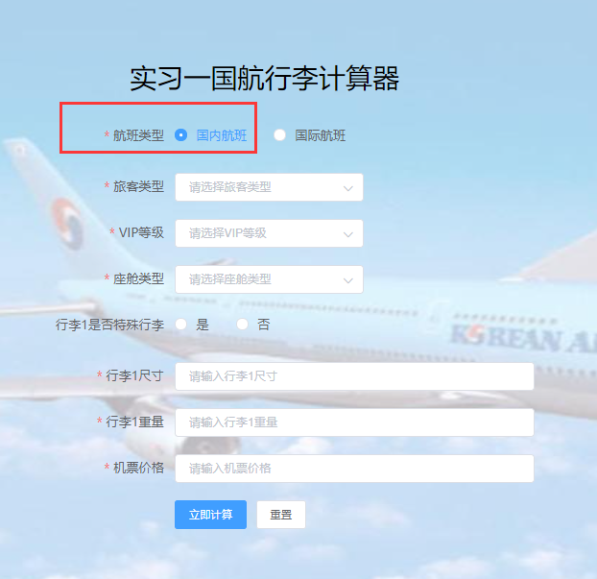

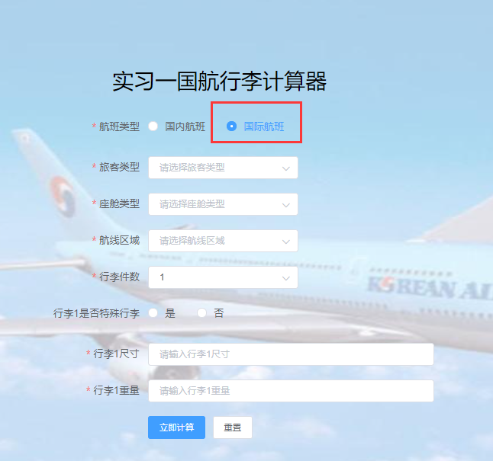

该软件的功能就是通过用户输入信息，信息包括选择国内或者国际航班、选择机票类型、座舱类型、VIP类型，行李类型、行李的数量、行李的尺寸和重量来进行计算该用户是否还需补交行李托运费，如果需要交，需要计算出要交多少钱。

## 2. 软件功能结构图（XMind）

### 软件整体功能结构图

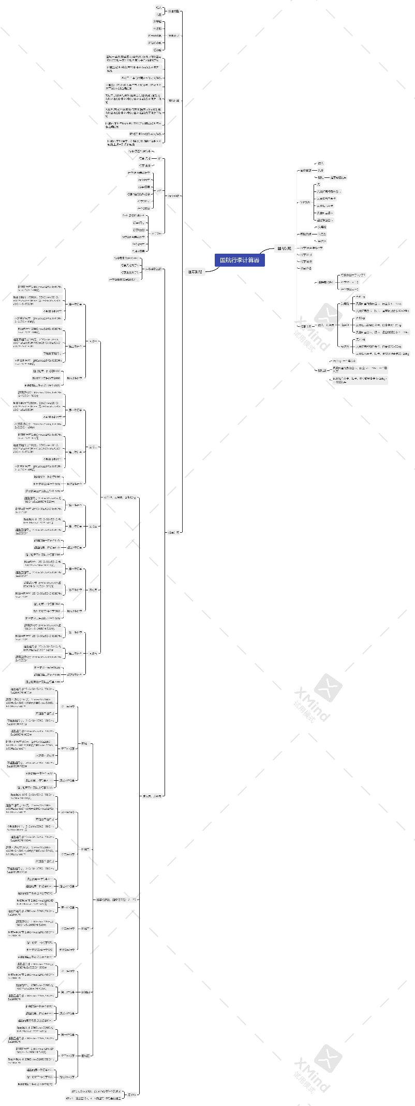

### 分层-国内航班

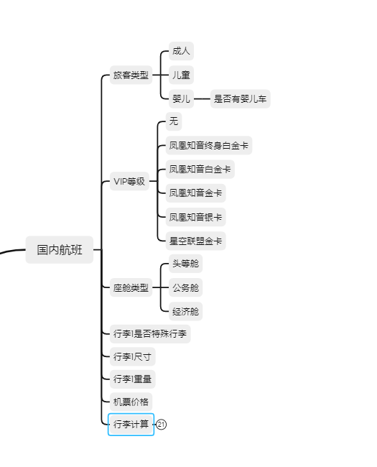

### 分层-国内航班行李计算

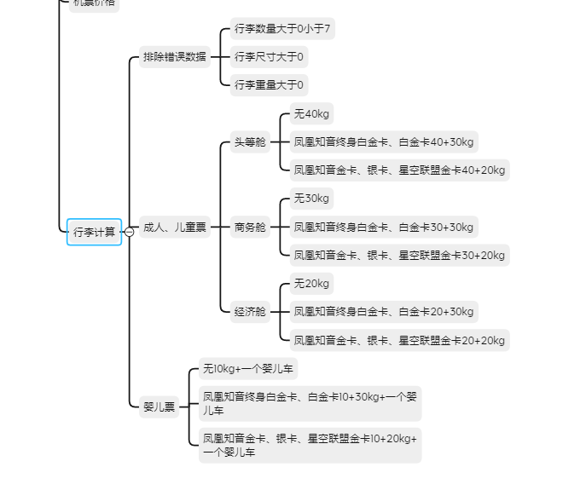

### 分层-国际航班

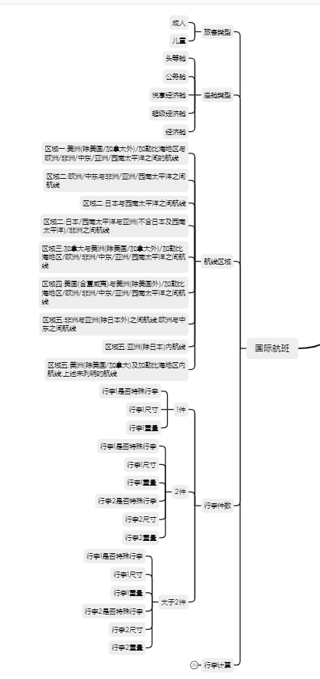

### 分层-国际航班行李计算-区域一

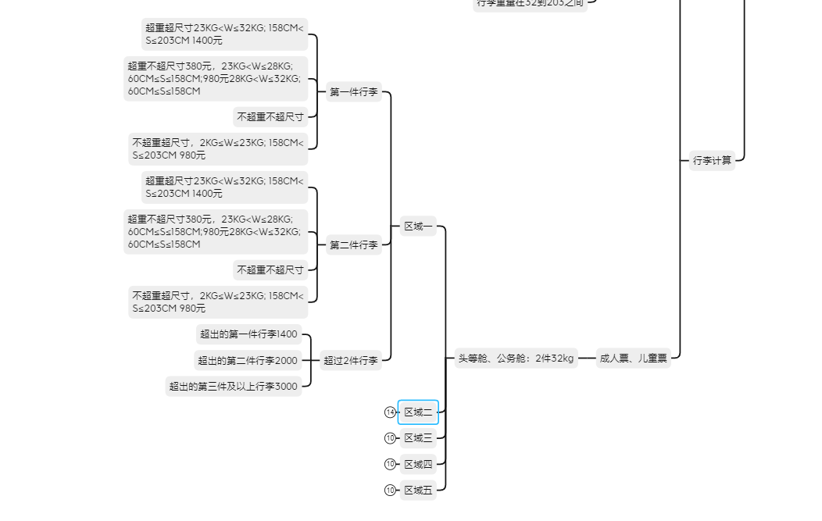

### 分层-国际航班行李计算-区域二、三

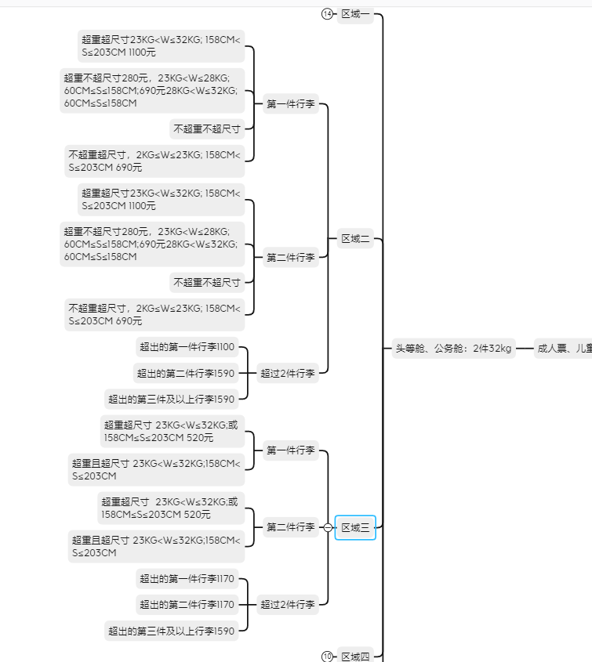

### 分层-国际航班行李计算-区域四、五

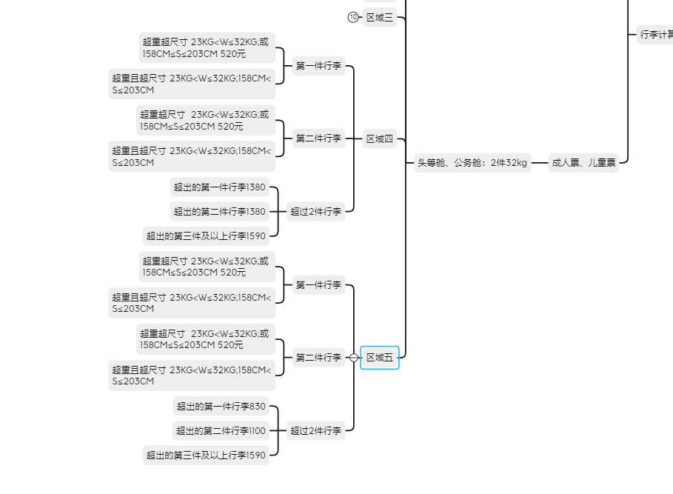

## 3. 黑盒测试

### 表1-1 国内航班等价类划分表

|  |  |  |  |
| --- | --- | --- | --- |
| 序号 | 输入条件 | 编号，有效等价类 | 编号，无效等价类 |
| 1 | 旅客类型 | 1.1成人、儿童  1.2婴儿 | 1.3其他类型 |
| 2 | 舱位类型 | 2.1头等舱  2.2公务舱  2.3经济舱 | 2.4其他舱 |
| 3 | VIP类型 | 3.1凤凰知音终身白金，白金卡  3.2凤凰知音金，银卡、星空联盟金卡  3.3无会员卡 | 3.4其他类型VIP |
| 4 | 普通行李尺寸 | 4.1长宽高之和大于等于60cm且长度之和小于等于203cm  4.2可免费携带行李长度小于等于100cm且宽度小于等于60cm且高度小于等于40cm | 4.3长宽高之和小于60cm  4.4长宽高之和大于203  4.5 长度大于100cm  4.6宽度大于60cm  4.7高度大于40cm  4.8长度小于或等于0cm  4.9宽度小于或等于0cm  4.10高度小于或等于0cm |
| 5 | 行李类型 | 5.1普通行李  5.2可免费携带特殊行李  5.3运动机械器具A  5.4运动机械器具B  5.5运动机械器具C  5.6其他特殊行李A  5.7其他特殊行李B  5.8其他特殊行李C  5.9其他特殊行李D  5.10其他特殊行李E | 5.11 其他类型 |
| 6 | 机票价格 | 6.1 大于0小于五位数的数字 | 6.2 小于或等于0的数字  6.3含有非数字的字符 |
| 7 | 其他特殊行李A,B,C,E重量 | 7.1大于等于2kg且小于等于32kg | 7.2小于2kg  7.3大于32kg |
| 8 | 普通行李，可免费携带特殊行李，运动器械器具类行李重量 | 8.1 大于等于2kg且小于等于45kg | 8.2 小于2kg  8.3大于45kg |
| 9 | 其他特殊行李D重量 | 9.1大于等于2kg且小于等于5kg | 9.1小于2kg  9.2大于5kg |

### 表1-2 国际航班等价类划分表

|  |  |  |  |
| --- | --- | --- | --- |
| 序号 | 输入条件 | 编号，有效等价类 | 编号，无效等价类 |
| 1 | 乘客类型 | 1.1成人票  1.2儿童票  1.3婴儿票 | 1.4其他乘客类型 |
| 2 | 舱位类型 | 2.1头等，商务舱  2.2悦享经济舱，超级经济舱  2.3经济舱(区域A)  2.4经济舱(区域B) | 2.5其他舱位类型 |
| 3 | 区域类型 | 3.1区域一  3.2区域二  3.3区域三  3.4区域四  3.5区域五 | 3.6其他区域 |
| 4 | 普通行李长度 | 4.1 长宽高之和大于等于60cm且小于等于203cm  4.2 可免费运输行李长宽高之和小于等于158 | 4.3长宽高之和小于60cm  4.4长宽高之和大于203cm  4.5长宽高之和大于158cm  4.6长度小于或等于0cm  4.7宽度小于或等于0cm  4.8高度小于或等于0cm |
| 5 | 行李类型 | 5.1普通行李  5.2可免费携带特殊行李  5.3运动机械器具A  5.4运动机械器具B  5.5运动机械器具C  5.6其他特殊行李A  5.7其他特殊行李B  5.8其他特殊行李C  5.9其他特殊行李D  5.10其他特殊行李E | 5.11 其他类型 |
| 6 | 其他特殊行李A,B,C,E | 6.1大于等于2kg且小于等于32kg | 6.2小于2kg  6.3大于32kg |
| 7 | 普通行李，可免费携带特殊行李，运动机械器具 | 7.1 大于等于2kg且小于等于45kg | 7.2 小于2kg  7.3大于45kg |
| 8 | 其他特殊行李D重量 | 8.1大于等于2kg且小于等于5kg | 8.1小于2kg  8.2大于5kg |
| 9 | 行李件数 | 9.1 大于0小于7的数字 | 9.2小于0  9.3大于7 |

### 表1-3 国内航班测试用例设计表

|  |  |  |  |  |
| --- | --- | --- | --- | --- |
| 用例编号 | 用例操作描述 | 测试数据 | 期望结果 | 覆盖等价类 |
| 1 | 边界检查——一般行李单件的最小体积<60cm 59cm | '国内航线','0 ', '头等舱','成人票','无',1000,[['普通行李',20,20,19,2]] | -1 | 4.3 |
| 2 | 边界检查——一般行李单件的最小体积==60cm 60cm | '国内航线','0 ', '头等舱','成人票','无',1000,[['普通行李',20,20,20,2]] | 0 | 4.1 |
| 3 | 边界检查——一般行李单件的最大体积>203cm 204cm | '国内航线','0 ', '头等舱','成人票','无',1000,[['普通行李',100,60,44,2]] | -1 | 4.4 |
| 4 | 边界检查——一般行李单件的长不能为0 0cm | '国内航线','0 ', '头等舱','成人票','无',1000,[['普通行李',0,40,43,2]] | -1 | 4.8 |
| 5 | 边界检查——一般行李单件的长不能为负数 -20cm | '国内航线','0 ', '头等舱','成人票','无',1000,[['普通行李',-100,20,43,2]] | -1 | 4.10 |
| 6 | 边界检查——长度大于100 101cm | '国内航线','0 ', '经济舱','成人票','凤凰知音终生白金卡、白金卡',1000,[['普通行李',101,40,40,22]] | 30 | 4.5 |
| 7 | 边界检查——长度小于等于100 100cm | '国内航线','0 ', '经济舱','成人票','凤凰知音终生白金卡、白金卡',1000,[['普通行李',100,40,40,22]] | 0 | 4.2 |
| 8 | 边界检查——一般行李单件的最大重量<2kg 1kg | '国内航线','0 ', '头等舱','成人票','无',1000,[['普通行李',30,40,40,1]] | -1 | 7.4 |
| 9 | 边界检查——一般行李单件的最大重量==45kg | '国内航线','0 ', '头等舱','成人票','无',1000,[['普通行李',30,40,40,45]] | 75 | 7.1 |
| 10 | 边界检查——其他特殊行李D单件的最大重量>5kg | '国内航线','0 ', '头等舱','成人票','无',1000,[['其他特殊行李D',0,0,0,6]] | -1 | 8.2 |
| 11 | 边界检查——其他特殊行李单件的最大重量==32kg | '国内航线','0 ', '头等舱','成人票','无',1000,[['其他特殊行李B',0,0,0,32]] | 3900 | 8.1 |
| 12 | 边界检查——价格为非纯数字 ss | '国内航线','0 ', '头等舱','成人票','无','ss',[['其他特殊行李B',0,0,0,32]] | -1 | 6.3 |
| 13 | 边界检查——价格小于等于0 -1 | '国内航线','0 ', '头等舱','成人票','无',-1,[['其他特殊行李B',0,0,0,32]] | -7 | 6.4 |
| 14 | 成人/儿童票头等舱携带总计<=40kg一般行李应该免费 | '国内航线','0 ','头等舱','成人票','无',1000,[['普通行李',30,40,40,20],['普通行李',100,60,40,20]] | 0 | 9.1 |
| 15 | 成人/儿童票头等舱+凤凰知音终生白金卡、白金卡 携带总计<=40kg 额外一件不超过30kg的行李 30，40kg行李，可免费运输 | '国内航线','0 ','头等舱','成人票','凤凰知音终生白金卡、白金卡',1000,[['普通行李',30,40,40,30],['普通行李',100,60,40,40]] | 465 | 1.1  2.1  4.4 |
| 16 | 成人/儿童票公务舱携带总计<=30kg一般行李应该免费 | '国内航线','0 ','公务舱','成人票','无',1000,[['普通行李',30,40,40,20],['普通行李',100,60,40,10]] | 0 | 1.1  2.1  3.3 |
| 17 | 成人/儿童票公务舱+凤凰知音金卡、银卡 携带总计<=30kg 额外一件不超过20kg的行李 21，20kg行李，无法免费运输，超重21kg | '国内航线','0 ','公务舱','成人票','凤凰知音金卡、银卡',1000,[['普通行李',30,40,40,21],['普通行李',100,60,40,30]] | 315 | 1.2  2.1  3.3 |
| 18 | 成人/儿童票经济舱携带总计30kg 超出10kg，结果应为150 | '国内航线','0 ','经济舱','成人票','无',1000,[['普通行李',30,40,40,10],['普通行李',100,60,40,20]] | 150 | 1.1  2.3  3.1 |
| 19 | 婴儿票携带总计<=10kg一般行李应该免费 | '国内航线','0 ','头等舱','婴儿票','无',1000,[['普通行李',30,40,40,5],['普通行李',100,60,40,5]] | 0 | 1.1  2.1  3.2 |
| 20 | 婴儿票+凤凰知音终生白金卡、白金卡 携带总计<=10kg 额外一件不超过30kg的行李 30，10kg行李，可免费运输 | '国内航线','0 ','头等舱','婴儿票','凤凰知音终生白金卡、白金卡',1000,[['普通行李',30,40,40,30],['普通行李',100,60,40,10]] | 0 | 1.1  2.2  3.2 |
| 21 | 成人票经济舱携带总计20kg 婴儿车需额外付费 | '国内航线','0 ','头等舱','成人票','无',1000,[['普通行李',30,40,40,20],['婴儿车',100,60,40,10]] | 150 | 1.1  2.2  3.2 |
| 22 | 婴儿票携带总计10kg 可免费携带一件婴儿车 两件车只有一件免费 | '国内航线','0 ','头等舱','婴儿票','无',1000,[['普通行李',30,40,40,10],['婴儿车',100,60,40,10],['婴儿车',100,60,40,10]] | 150 | 1.1  2.3  3.2 |
| 23 | 可免费运输的特殊行李<=45kg 免费 | '国内航线','0 ','头等舱','婴儿票','无',1000,[['可免费运输的特殊行李',100,60,40,10]] | 0 | 1.1  2.3  3.3  5.1  5.2 |
| 24 | 成人/儿童票头等舱携带总计 42kg 行李超重2kg | '国内航线','0 ','头等舱','成人票','无',1000,[['运动机械器具A',30,40,40,22],['其他特殊行李A',100,60,40,20]] | 30 | 1.1  2.2  3.1  5.4  5.5  5.7  5.8  5.9  5.10 |
| 25 | 运动类机械B 重量大于2kg小于等于23kg | '国内航线','0 ','头等舱','成人票','无',1000,[['运动机械器具B',30,40,40,22]] | 2600 | 1.1  2.1  3.1  5.1 |
| 26 | 运动类机械B 重量大于23kg小于等于32kg | '国内航线','0 ','头等舱','成人票','无',1000,[['运动机械器具B',30,40,40,24]] | 3900 | 1.1  2.1  3.1  5.1  5.3  5.9 |
| 27 | 其他特殊行李D 重量大于2kg小于等于5kg | '国内航线','0 ','头等舱','成人票','无',1000,[['其他特殊行李D',30,40,40,4]] | 1300 | 1.1  2.2  3.1  5.1 |
| 28 | 其他特殊行李E 重量大于2kg小于等于8kg | '国内航线','0 ','头等舱','成人票','无',1000,[['其他特殊行李E',30,40,40,4]] | 3900 | 1.1  2.2  3.1  5.1  5.3  5.6 |
| 29 | 其他特殊行李E 重量大于23kg小于等于32kg | '国内航线','0 ','头等舱','成人票','无',1000,[['其他特殊行李E',30,40,40,24]] | 7800 | 1.1  2.2  3.2  5.1  5.3 |

### 表1-4 国际航班测试用例设计表

|  |  |  |  |  |
| --- | --- | --- | --- | --- |
| 用例编号 | 用例操作描述 | 测试数据 | 期望结果 | 覆盖等价类 |
| 1 | 边界检查——一般行李单件的最大重量>32kg 33kg | '国际航线','区域一', '头等，公务舱','成人票',' ',0,[['普通行李',30,40,40,33]] | -1 | 4.3 |
| 2 | 边界检查——一般行李单件的最大重量==32kg | '国际航线','区域一', '头等，公务舱','成人票',' ',0,[['普通行李',30,40,40,32]] | 0 | 4.1 |
| 3 | 边界检查——一般行李单件的最小体重<2kg 1kg | '国际航线','区域一', '头等，公务舱','成人票',' ',0,[['普通行李',30,40,40,1]] | -1 | 4.4 |
| 4 | 边界检查——一般行李单件的最小体重==2kg | '国际航线','区域一', '头等，公务舱','成人票',' ',0,[['普通行李',30,40,40,2]] | 0 | 4.8 |
| 5 | 边界检查——特殊行李单件的最大体重>45kg 53kg | '国际航线','区域一', '头等，公务舱','成人票',' ',0,[['运动机械器具B',30,40,40,53]] | -1 | 4.10 |
| 6 | 边界检查——其他特殊行李B单件的最大体重>32kg 33kg | '国际航线','区域一', '头等，公务舱','成人票',' ',0,[['其他特殊行李B',30,40,40,33]] | -1 | 4.5 |
| 7 | 边界检查——其他特殊行李B单件的最大体重==32kg 32kg | '国际航线','区域一', '头等，公务舱','成人票',' ',0,[['其他特殊行李B',30,40,40,32]] | 3900 | 4.2 |
| 8 | 边界检查——其他特殊行李D单件的最大体重>5kg 13kg | '国际航线','区域一', '头等，公务舱','成人票',' ',0,[['其他特殊行李D',30,40,40,13]] | -1 | 7.4 |
| 9 | 边界检查——一般行李单件免费运输的最大体积<=158cm 158cm | '国际航线','区域一', '头等，公务舱','成人票','无',0,[['普通行李',80,45,33,2]] | 0 | 7.1 |
| 10 | 持成人票或者儿童票的头等、公务舱旅客可免费运输两件小于32kg的物品 | '国际航线','区域一', '头等，公务舱','成人票','无',0,[['普通行李',60,45,33,32],['普通行李',60,45,33,32]] | 0 | 8.2 |
| 11 | 持成人票或者儿童票的头等、公务舱旅客在区域一有一件超重(23，28]但不超尺寸 27kg | '国际航线','区域一', '头等，公务舱','成人票','无',0,[['普通行李',60,45,33,32],['普通行李',60,45,33,32],['普通行李',60,45,33,27]] | 1780 | 8.1 |
| 12 | 持成人票或者儿童票的头等、公务舱旅客在区域一有一件超重(28，32]但不超尺寸 30kg | '国际航线','区域一', '头等，公务舱','成人票','无',0,[['普通行李',60,45,33,32],['普通行李',60,45,33,32],['普通行李',60,45,33,30]] | 2380 | 6.3 |
| 13 | 持成人票或者儿童票的头等、公务舱旅客在区域一有一件不超重但超尺寸(>158) 160cm | '国际航线','区域一', '头等，公务舱','成人票','无',0,[['普通行李',60,45,33,32],['普通行李',60,45,33,32],['普通行李',80,65,33,3]] | 2380 | 6.4 |
| 14 | 持成人票或者儿童票的头等、公务舱旅客在区域一有一件超重且超尺寸(>158) 24kg，160cm | '国际航线','区域一', '头等，公务舱','成人票','无',0,[['普通行李',60,45,33,32],['普通行李',60,45,33,32],['普通行李',80,65,33,24]] | 2800 | 9.1 |
| 15 | 持成人票或者儿童票的头等、公务舱旅客在区域一有两件额外行李，都为超重但不超尺寸 | '国际航线','区域一', '头等，公务舱','成人票','无',0,[['普通行李',60,45,33,32],['普通行李',60,45,33,32],  ['普通行李',60,45,33,27],['普通行李',60,45,33,27]] | 2760 | 1.1  2.1  4.4 |
| 16 | 持成人票或者儿童票的头等、公务舱旅客在区域一有四件额外行李，都为超重但不超尺寸 | '国际航线','区域一', '头等，公务舱','成人票','无',0,[['普通行李',60,45,33,32],['普通行李',60,45,33,32],  ['普通行李',60,45,33,27],['普通行李',60,45,33,27],['普通行李',60,45,33,27],['普通行李',60,45,33,27]] | 4520 | 1.1  2.1  3.3 |
| 17 | 持成人票或者儿童票的头等、公务舱旅客在区域二有一件超重(23，28]但不超尺寸 27kg | '国际航线','区域二', '头等，公务舱','成人票','无',0,[['普通行李',60,45,33,32],['普通行李',60,45,33,32],['普通行李',60,45,33,27]] | 1380 | 1.2  2.1  3.3 |
| 18 | 持成人票或者儿童票的头等、公务舱旅客在区域二有一件超重(28，32]但不超尺寸 30kg | '国际航线','区域二', '头等，公务舱','成人票','无',0,[['普通行李',60,45,33,32],['普通行李',60,45,33,32],['普通行李',60,45,33,30]] | 1790 | 1.1  2.3  3.1 |
| 19 | 持成人票或者儿童票的头等、公务舱旅客在区域二有一件不超重但超尺寸(>158) 160cm | '国际航线','区域二', '头等，公务舱','成人票','无',0,[['普通行李',60,45,33,32],['普通行李',60,45,33,32],['普通行李',80,65,33,3]] | 1790 | 1.1  2.1  3.2 |
| 20 | 持成人票或者儿童票的头等、公务舱旅客在区域二有一件超重且超尺寸(>158) 24kg，160cm | '国际航线','区域二', '头等，公务舱','成人票','无',0,[['普通行李',60,45,33,32],['普通行李',60,45,33,32],['普通行李',80,65,33,24]] | 2280 | 1.1  2.2  3.2 |
| 21 | 持成人票或者儿童票的头等、公务舱旅客在区域二有四件额外行李，都为超重但不超尺寸 | '国际航线','区域二', '头等，公务舱','成人票','无',0,[['普通行李',60,45,33,32],['普通行李',60,45,33,32],  ['普通行李',60,45,33,27],['普通行李',60,45,33,27],['普通行李',60,45,33,27],['普通行李',60,45,33,27]] | 2710 | 1.1  2.2  3.2 |
| 22 | '持成人票或者儿童票的头等、公务舱旅客在区域三有一件超重(23，28]但不超尺寸 27kg | '国际航线','区域三', '头等，公务舱','成人票','无',0,[['普通行李',60,45,33,32],['普通行李',60,45,33,32],['普通行李',60,45,33,27]] | 1690 | 1.1  2.3  3.2 |
| 23 | 持成人票或者儿童票的头等、公务舱旅客在区域三有一件不超重但超尺寸(>158) 160cm | '国际航线','区域三', '头等，公务舱','成人票','无',0,[['普通行李',60,45,33,32],['普通行李',60,45,33,32],['普通行李',80,65,33,3]] | 1690 | 1.1  2.3  3.3  5.1  5.2 |
| 24 | 持成人票或者儿童票的头等、公务舱旅客在区域三有一件超重且超尺寸(>158) 24kg，160cm | '国际航线','区域三', '头等，公务舱','成人票','无',0,[['普通行李',60,45,33,32],['普通行李',60,45,33,32],['普通行李',80,65,33,24]] | 1690 | 1.1  2.2  3.1  5.4  5.5  5.7  5.8  5.9  5.10 |
| 25 | 持成人票或者儿童票的头等、公务舱旅客在区域三有四件额外行李，都为超重但不超尺寸 | '国际航线','区域三', '头等，公务舱','成人票','无',0,[['普通行李',60,45,33,32],['普通行李',60,45,33,32],  ['普通行李',60,45,33,27],['普通行李',60,45,33,27],['普通行李',60,45,33,27],['普通行李',60,45,33,27]] | 3670 | 1.1  2.1  3.1  5.1 |
| 26 | 持成人票或者儿童票的头等、公务舱旅客在区域四有一件超重(23，28]但不超尺寸 27kg | '国际航线','区域四', '头等，公务舱','成人票','无',0,[['普通行李',60,45,33,32],['普通行李',60,45,33,32],['普通行李',60,45,33,27]] | 2070 | 1.1  2.1  3.1  5.1  5.3  5.9 |
| 27 | 持成人票或者儿童票的头等、公务舱旅客在区域四有一件不超重但超尺寸(>158) 160cm | '国际航线','区域四', '头等，公务舱','成人票','无',0,[['普通行李',60,45,33,32],['普通行李',60,45,33,32],['普通行李',80,65,33,3]] | 2420 | 1.1  2.2  3.1  5.1 |
| 28 | 持成人票或者儿童票的头等、公务舱旅客在区域四有两件额外行李，都为超重但不超尺寸 | '国际航线','区域四', '头等，公务舱','成人票','无',0,[['普通行李',60,45,33,32],['普通行李',60,45,33,32],  ['普通行李',60,45,33,27],['普通行李',60,45,33,27]] | 2760 | 1.1  2.2  3.1  5.1  5.3  5.6 |
| 29 | 持成人票或者儿童票的头等、公务舱旅客在区域四有四件额外行李，都为超重但不超尺寸 | '国际航线','区域四', '头等，公务舱','成人票','无',0,[['普通行李',60,45,33,32],['普通行李',60,45,33,32],  ['普通行李',60,45,33,27],['普通行李',60,45,33,27],['普通行李',60,45,33,27],['普通行李',60,45,33,27]] | 4350 | 1.1  2.2  3.2  5.1  5.3 |
| 30 | 持成人票或者儿童票的头等、公务舱旅客在区域五有一件超重(23，28]但不超尺寸 27kg | '国际航线','区域五', '头等，公务舱','成人票','无',0,[['普通行李',60,45,33,32],['普通行李',60,45,33,32],['普通行李',60,45,33,27]] | 1040 | 6.1 |
| 31 | 持成人票或者儿童票的头等、公务舱旅客在区域五有一件超重(28，32]但不超尺寸 30kg | '国际航线','区域五', '头等，公务舱','成人票','无',0,[['普通行李',60,45,33,32],['普通行李',60,45,33,32],['普通行李',60,45,33,30]] | 1350 | 7.1 |
| 32 | 持成人票或者儿童票的头等、公务舱旅客在区域五有一件不超重但超尺寸(>158) 160cm | '国际航线','区域五', '头等，公务舱','成人票','无',0,[['普通行李',60,45,33,32],['普通行李',60,45,33,32],['普通行李',80,65,33,3]] | 1660 | 1.1  4.2 |
| 33 | 持成人票或者儿童票的头等、公务舱旅客在区域五有四件额外行李，都为超重但不超尺寸 | '国际航线','区域五', '头等，公务舱','成人票','无',0,[['普通行李',60,45,33,32],['普通行李',60,45,33,32],  ['普通行李',60,45,33,27],['普通行李',60,45,33,27],['普通行李',60,45,33,27],['普通行李',60,45,33,27]] | 2430 | 7.1  8.1  5.3 |
| 34 | 经济舱A旅客可免费运输一件小于23kg的物品 | '国际航线','区域二', '经济舱(区域A)','成人票','无',0,[['普通行李',60,45,33,23]] | 0 | 2.1  2.2 |
| 35 | 经济舱A旅客不可以选择区域一 选择区域一 | '国际航线','区域一', '经济舱(区域A)','成人票','无',0,[['普通行李',60,45,33,23]] | -1 | 2.3 |
| 36 | 经济舱A旅客可免费运输二件小于23kg的物品 2件物品 一件大于23kg | '国际航线','区域二', '经济舱(区域B)','成人票','无',0,[['普通行李',60,45,33,23],['普通行李',60,45,33,30]] | 1790 | 2.4 |
| 37 | 经济舱B客可以选择区域一 选择区域一 | '国际航线','区域一', '经济舱(区域B)','成人票','无',0,[['普通行李',60,45,33,23]] | 0 | 2.3  2.4 |
| 38 | 其他特殊行李E 重量大于8kg小于等于23kg | '国际航线','区域一','头等，公务舱','成人票','无',0,[['其他特殊行李E',30,40,40,15]] | 5200 | 8.1 |

## 4. 白盒测试

### 4.1 模块/函数1-后端整体计算函数

#### 4.1.1 功能

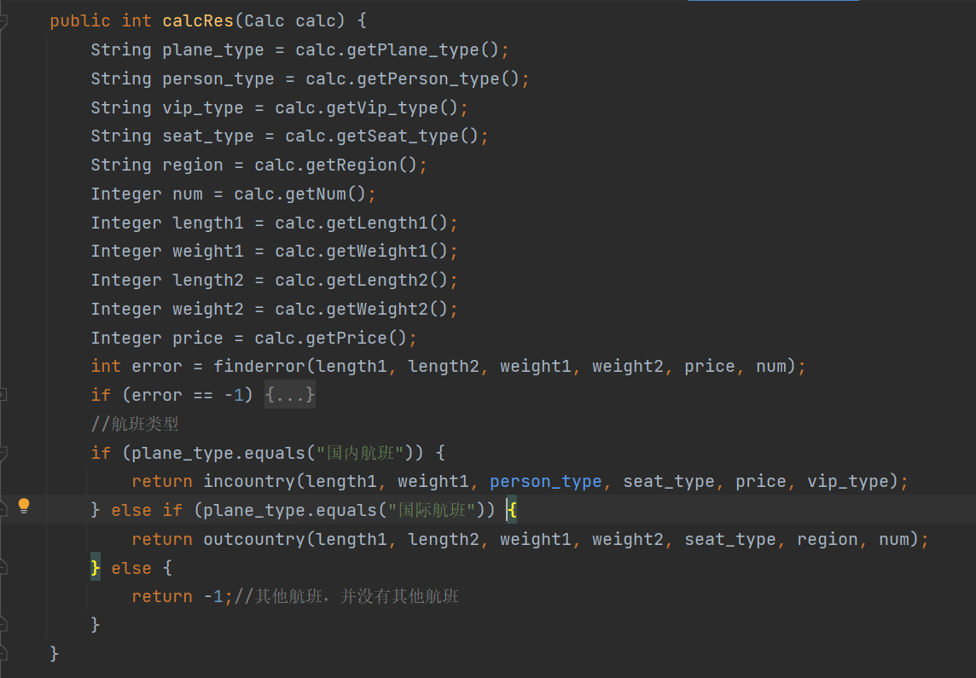

该函数的功能是将前端传到后端的表单实例化，每一个属性确定为一个对象，好为后面计算做准备。首先判断输入的数据是否有错误数据，比如小于0、超出计算范围的数据。如果有，直接就返回错误；如果数据没有错误，再根据plane_type的类型进行判断，首先判断是否是国内航班，如果是则返回国内计算函数的res，如果不是，则继续判断是否是国际航班，如果是，则返回国际计算函数的res，如果都不是，则最后返回-1，表示错误数据。

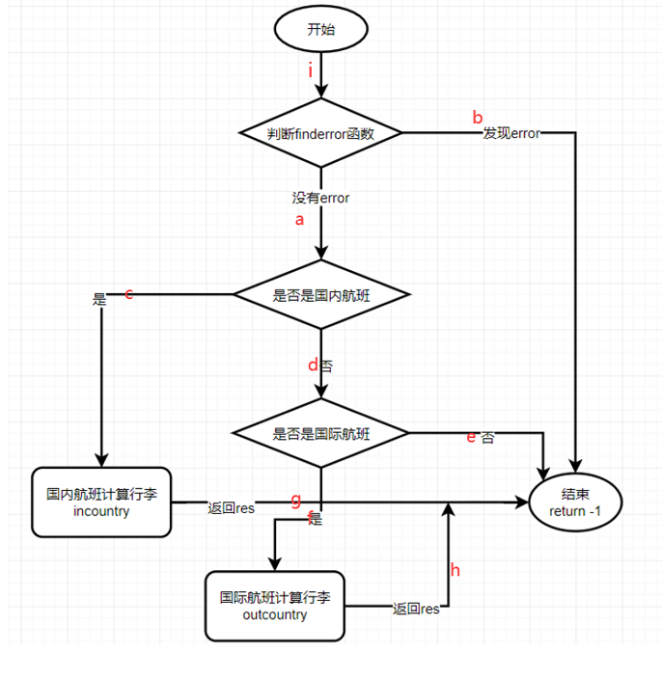

#### 4.1.2 输入

public int calcRes(Calc calc)

输入是Calc类对象，类成员是前端传回的表单的实体类。

#### 4.1.3 输出

错误数据返回-1

运行正常返回的是行李托运的计算结果

#### 4.1.4 测试用例

**表2-1 测试用例设计表**

|  |  |  |  |
| --- | --- | --- | --- |
| 用例编号 | 通过路径 | 测试数据 | 期望结果 |
| 1 | i-a-c-g | plane_type:国内航班 person_type:p-1 vip_type:v-1 seat_type:s-2 region:0 num:1 spec1:普通行李 spec2: length1:100 weight1:100 length2:0 weight2:0 price:1000 | 450 |
| 2 | i-a-c-g | plane_type:国内航班 person_type:p-1 vip_type:v-1 seat_type:s-2 region:0 num:1 spec1:普通行李 spec2: length1:200 weight1:100 length2:0 weight2:0 price:1000 | 550 |
| 3 | i-a-c-g | plane_type:国内航班 person_type:p-1 vip_type:v-1 seat_type:s-2 region:0 num:1 spec1:普通行李 spec2: length1:200 weight1:200 length2:0 weight2:0 price:1000 | 2050 |
| 4 | i-a-c-g | plane_type:国内航班 person_type:p-1 vip_type:v-1 seat_type:s-2 region:0 num:1 spec1:普通行李 spec2: length1:100 weight1:50 length2:0 weight2:0 price:1000 | 0 |
| 5 | i-a-c-g | plane_type:国内航班 person_type:p-3 vip_type:v-1 seat_type:s-2 region:0 num:1 spec1:普通行李 spec2: length1:100 weight1:150 length2:0 weight2:0 price:1000 | 1650 |
| 6 | i-a-d-f-h | "plane_type": "国际航班",  "person_type": "p-1",  "vip_type": "无",  "seat_type": "s-2",  "region": "r-1-1",  "num": "1",  "spec1": "普通行李",  "spec2": "",  "length1": "100",  "weight1": "25",  "length2": "0",  "weight2": "0",  "price": "0" | 0 |
| 7 | i-a-d-f-h | "plane_type": "国际航班",  "person_type": "p-1",  "vip_type": "无",  "seat_type": "s-2",  "region": "r-1-1",  "num": "1",  "spec1": "普通行李",  "spec2": "",  "length1": "200",  "weight1": "25",  "length2": "0",  "weight2": "0",  "price": "0" | 960 |
| 8 | i-a-d-f-h | "plane_type": ""国际航班",  "person_type": "p-1",  "vip_type": "无",  "seat_type": "s-2",  "region": "r-1-1",  "num": "2",  "spec1": "普通行李",  "spec2": "可免费运输的特殊行李",  "length1": "200",  "weight1": "25",  "length2": "100",  "weight2": "32",  "price": "0" | 960 |
| 9 | i-a-d-f-h | "plane_type": "国际航班",  "person_type": "p-1",  "vip_type": "无",  "seat_type": "s-2",  "region": "r-1-1",  "num": "2",  "spec1": "普通行李",  "spec2": "可免费运输的特殊行李",  "length1": "200",  "weight1": "25",  "length2": "150",  "weight2": "32",  "price": "0" | 960 |
| 10 | i-a-d-f-h | "plane_type": "国际航班",  "person_type": "p-1",  "vip_type": "无",  "seat_type": "s-2",  "region": "r-1-1",  "num": "2",  "spec1": "普通行李",  "spec2": "可免费运输的特殊行李",  "length1": "200",  "weight1": "25",  "length2": "200",  "weight2": "32",  "price": "0" | 1960 |
| 11 | i-a-d-e | "plane_type": "",  "person_type": "p-1",  "vip_type": "无",  "seat_type": "s-2",  "region": "r-1-1",  "num": "1",  "spec1": "普通行李",  "spec2": "",  "length1": "100",  "weight1": "25",  "length2": "0",  "weight2": "0",  "price": "0" | -1 |
| 12 | i-a-d-e | "plane_type": "航班",  "person_type": "p-1",  "vip_type": "无",  "seat_type": "s-2",  "region": "r-1-1",  "num": "1",  "spec1": "普通行李",  "spec2": "",  "length1": "100",  "weight1": "25",  "length2": "0",  "weight2": "0",  "price": "0" | -1 |
| 13 | i-a-d-e | "plane_type": "国际",  "person_type": "p-1",  "vip_type": "无",  "seat_type": "s-2",  "region": "r-1-1",  "num": "1",  "spec1": "普通行李",  "spec2": "",  "length1": "100",  "weight1": "25",  "length2": "0",  "weight2": "0",  "price": "0" | -1 |
| 14 | i-a-d-e | "plane_type": "1234",  "person_type": "p-1",  "vip_type": "无",  "seat_type": "s-2",  "region": "r-1-1",  "num": "1",  "spec1": "普通行李",  "spec2": "",  "length1": "100",  "weight1": "25",  "length2": "0",  "weight2": "0",  "price": "0" | -1 |
| 15 | i-a-d-e | "plane_type": "国班",  "person_type": "p-1",  "vip_type": "无",  "seat_type": "s-2",  "region": "r-1-1",  "num": "1",  "spec1": "普通行李",  "spec2": "",  "length1": "100",  "weight1": "25",  "length2": "0",  "weight2": "0",  "price": "0" | -1 |
| 16 | i-b | plane_type:国内航班 person_type:p-1 vip_type:v-1 seat_type:s-2 region:0 num:1 spec1:普通行李 spec2: length1:-100 weight1:-100 length2:0 weight2:0 price:1000 | -1 |
| 17 | i-b | plane_type:国内航班 person_type:p-1 vip_type:v-1 seat_type:s-2 region:0 num:1 spec1:普通行李 spec2: length1:-100 weight1:100 length2:0 weight2:0 price:1000 | -1 |
| 18 | i-b | "plane_type": "国际航班",  "person_type": "p-1",  "vip_type": "无",  "seat_type": "s-2",  "region": "r-1-1",  "num": "1",  "spec1": "普通行李",  "spec2": "",  "length1": "100",  "weight1": "-25",  "length2": "0",  "weight2": "0",  "price": "0" | -1 |
| 19 | i-b | "plane_type": "国际航班",  "person_type": "p-1",  "vip_type": "无",  "seat_type": "s-2",  "region": "r-1-1",  "num": "1",  "spec1": "普通行李",  "spec2": "",  "length1": "-100",  "weight1": "25",  "length2": "0",  "weight2": "0",  "price": "0" | -1 |
| 20 | i-b | "plane_type": "国际航班",  "person_type": "p-1",  "vip_type": "无",  "seat_type": "s-2",  "region": "r-1-1",  "num": "0",  "spec1": "普通行李",  "spec2": "",  "length1": "100",  "weight1": "25",  "length2": "0",  "weight2": "0",  "price": "0" | -1 |

### 模块/函数2-后端国内航班行李计算函数

#### 功能

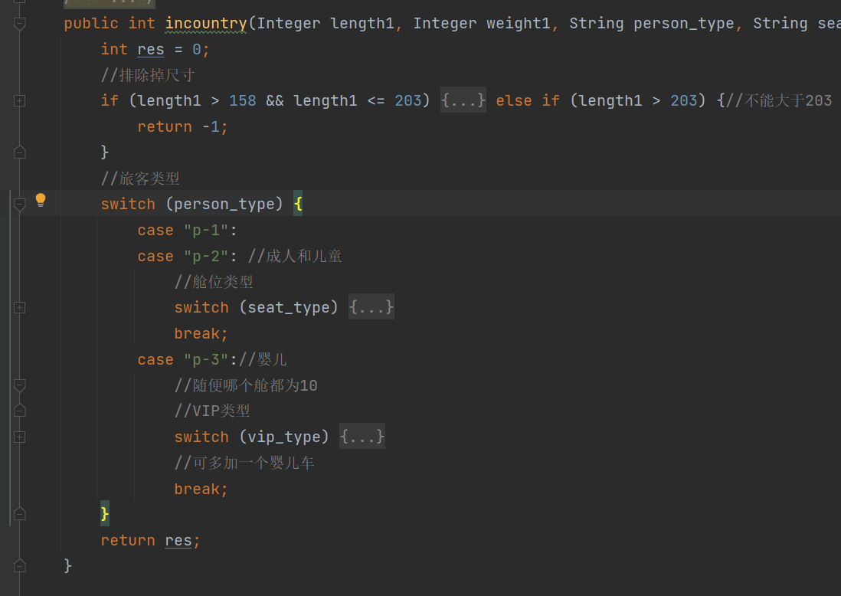

该函数主要是计算国内航班的行李托运，首先形参有用户填入的信息，根据这些信息进行计算。首先选择出尺寸大于158和小于203的行李进行单独增加100元费用，然后在排除掉尺寸大于203的行李，直接返回error；当没有错误数据之后，开始计算，先按照游客类型进行区分，再按照舱座类型进行区分，最后再按照VIP等级区分，不同的选择，所对应的免费托运行李的额度不一样，相对应的费用也不一样。

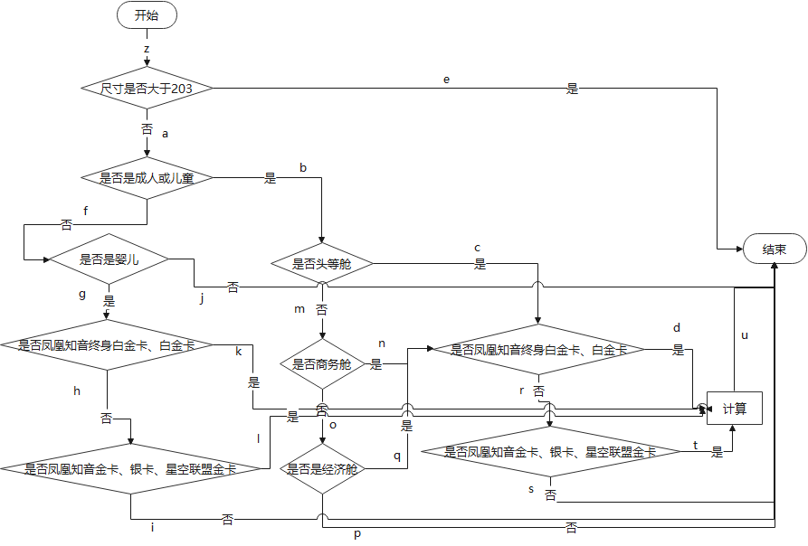

#### 输入

表单中的行李尺寸、行李重量、旅客类型、舱座类型、VIP类型、价格

#### 输出

错误数据返回-1；

运行正常返回的是行李托运计算结果

#### 测试用例

**表2-2 测试用例设计表**

|  |  |  |  |
| --- | --- | --- | --- |
| 用例编号 | 通过路径 | 测试数据 | 期望结果 |
| 1 | z-a-b-c-d-u | "plane_type": "国内航班",  "person_type": "p-1",  "vip_type": "v-1",  "seat_type": "s-2",  "region": "0",  "num": "1",  "spec1": "普通行李",  "spec2": "",  "length1": "100",  "weight1": "100",  "length2": "0",  "weight2": "0",  "price": "1000" | 450 |
| 2 | z-a-b-c-d-u | "plane_type": "国内航班",  "person_type": "p-1",  "vip_type": "v-1",  "seat_type": "s-2",  "region": "0",  "num": "1",  "spec1": "普通行李",  "spec2": "",  "length1": "100",  "weight1": "150",  "length2": "0",  "weight2": "0",  "price": "1000" | 1200 |
| 3 | z-a-b-c-d-u | "plane_type": "国内航班",  "person_type": "p-1",  "vip_type": "v-1",  "seat_type": "s-2",  "region": "0",  "num": "1",  "spec1": "普通行李",  "spec2": "",  "length1": "100",  "weight1": "200",  "length2": "0",  "weight2": "0",  "price": "1000" | 1590 |
| 4 | z-a-b-c-d-u | "plane_type": "国内航班",  "person_type": "p-1",  "vip_type": "v-1",  "seat_type": "s-2",  "region": "0",  "num": "1",  "spec1": "普通行李",  "spec2": "",  "length1": "150",  "weight1": "100",  "length2": "0",  "weight2": "0",  "price": "1000" | 450 |
| 5 | z-a-b-c-d-u | "plane_type": "国内航班",  "person_type": "p-1",  "vip_type": "v-1",  "seat_type": "s-2",  "region": "0",  "num": "1",  "spec1": "普通行李",  "spec2": "",  "length1": "200",  "weight1": "100",  "length2": "0",  "weight2": "0",  "price": "1000" | 550 |
| 6 | z-a-b-c-r-t-u | "plane_type": "国内航班",  "person_type": "p-1",  "vip_type": "v-5",  "seat_type": "s-2",  "region": "0",  "num": "1",  "spec1": "普通行李",  "spec2": "",  "length1": "100",  "weight1": "100",  "length2": "0",  "weight2": "0",  "price": "1000" | 600 |
| 7 | z-a-b-c-r-t-u | "plane_type": "国内航班",  "person_type": "p-1",  "vip_type": "v-5",  "seat_type": "s-2",  "region": "0",  "num": "1",  "spec1": "普通行李",  "spec2": "",  "length1": "100",  "weight1": "150",  "length2": "0",  "weight2": "0",  "price": "1000" | 1350 |
| 8 | z-a-b-c-r-t-u | "plane_type": "国内航班",  "person_type": "p-1",  "vip_type": "v-5",  "seat_type": "s-2",  "region": "0",  "num": "1",  "spec1": "普通行李",  "spec2": "",  "length1": "100",  "weight1": "200",  "length2": "0",  "weight2": "0",  "price": "1000" | 2100 |
| 9 | z-a-b-c-r-t-u | "plane_type": "国内航班",  "person_type": "p-1",  "vip_type": "v-5",  "seat_type": "s-2",  "region": "0",  "num": "1",  "spec1": "普通行李",  "spec2": "",  "length1": "150",  "weight1": "100",  "length2": "0",  "weight2": "0",  "price": "1000" | 600 |
| 10 | z-a-b-c-r-t-u | "plane_type": "国内航班",  "person_type": "p-1",  "vip_type": "v-5",  "seat_type": "s-2",  "region": "0",  "num": "1",  "spec1": "普通行李",  "spec2": "",  "length1": "200",  "weight1": "100",  "length2": "0",  "weight2": "0",  "price": "1000" | 700 |
| 11 | z-a-b-c-r-s | "plane_type": "国内航班",  "person_type": "p-1",  "vip_type": "",  "seat_type": "s-2",  "region": "0",  "num": "1",  "spec1": "普通行李",  "spec2": "",  "length1": "200",  "weight1": "100",  "length2": "0",  "weight2": "0",  "price": "1000" | -1 |
| 12 | z-a-b-c-r-s | "plane_type": "国内航班",  "person_type": "p-1",  "vip_type": "v-6",  "seat_type": "s-2",  "region": "0",  "num": "1",  "spec1": "普通行李",  "spec2": "",  "length1": "200",  "weight1": "100",  "length2": "0",  "weight2": "0",  "price": "1000" | -1 |
| 13 | z-a-b-c-r-s | "plane_type": "国内航班",  "person_type": "p-1",  "vip_type": "v-7",  "seat_type": "s-2",  "region": "0",  "num": "1",  "spec1": "普通行李",  "spec2": "",  "length1": "200",  "weight1": "100",  "length2": "0",  "weight2": "0",  "price": "1000" | -1 |
| 14 | z-a-b-c-r-s | "plane_type": "国内航班",  "person_type": "p-1",  "vip_type": "v-8",  "seat_type": "s-2",  "region": "0",  "num": "1",  "spec1": "普通行李",  "spec2": "",  "length1": "200",  "weight1": "100",  "length2": "0",  "weight2": "0",  "price": "1000" | -1 |
| 15 | z-a-b-c-r-s | "plane_type": "国内航班",  "person_type": "p-1",  "vip_type": "v-9",  "seat_type": "s-2",  "region": "0",  "num": "1",  "spec1": "普通行李",  "spec2": "",  "length1": "200",  "weight1": "100",  "length2": "0",  "weight2": "0",  "price": "1000" | -1 |
| 16 | z-a-b-m-n-r-t-u | "plane_type": "国内航班",  "person_type": "p-1",  "vip_type": "v-5",  "seat_type": "s-3",  "region": "0",  "num": "1",  "spec1": "普通行李",  "spec2": "",  "length1": "100",  "weight1": "100",  "length2": "0",  "weight2": "0",  "price": "1000" | 750 |
| 17 | z-a-b-m-n-r-t-u | "plane_type": "国内航班",  "person_type": "p-1",  "vip_type": "v-5",  "seat_type": "s-3",  "region": "0",  "num": "1",  "spec1": "普通行李",  "spec2": "",  "length1": "100",  "weight1": "150",  "length2": "0",  "weight2": "0",  "price": "1000" | 1500 |
| 18 | z-a-b-m-n-r-t-u | "plane_type": "国内航班",  "person_type": "p-1",  "vip_type": "v-5",  "seat_type": "s-3",  "region": "0",  "num": "1",  "spec1": "普通行李",  "spec2": "",  "length1": "100",  "weight1": "200",  "length2": "0",  "weight2": "0",  "price": "1000" | 2250 |
| 19 | z-a-b-m-n-r-t-u | "plane_type": "国内航班",  "person_type": "p-1",  "vip_type": "v-5",  "seat_type": "s-3",  "region": "0",  "num": "1",  "spec1": "普通行李",  "spec2": "",  "length1": "150",  "weight1": "100",  "length2": "0",  "weight2": "0",  "price": "1000" | 750 |
| 20 | z-a-b-m-n-r-t-u | "plane_type": "国内航班",  "person_type": "p-1",  "vip_type": "v-5",  "seat_type": "s-3",  "region": "0",  "num": "1",  "spec1": "普通行李",  "spec2": "",  "length1": "200",  "weight1": "100",  "length2": "0",  "weight2": "0",  "price": "1000" | 850 |
| 21 | z-a-b-m-n-r-s | "plane_type": "国内航班",  "person_type": "p-1",  "vip_type": "",  "seat_type": "s-3",  "region": "0",  "num": "1",  "spec1": "普通行李",  "spec2": "",  "length1": "200",  "weight1": "100",  "length2": "0",  "weight2": "0",  "price": "1000" | -1 |
| 22 | z-a-b-m-n-r-s | "plane_type": "国内航班",  "person_type": "p-1",  "vip_type": "v-6",  "seat_type": "s-3",  "region": "0",  "num": "1",  "spec1": "普通行李",  "spec2": "",  "length1": "200",  "weight1": "100",  "length2": "0",  "weight2": "0",  "price": "1000" | -1 |
| 23 | z-a-b-m-n-r-s | "plane_type": "国内航班",  "person_type": "p-1",  "vip_type": "v-7",  "seat_type": "s-3",  "region": "0",  "num": "1",  "spec1": "普通行李",  "spec2": "",  "length1": "200",  "weight1": "100",  "length2": "0",  "weight2": "0",  "price": "1000" | -1 |
| 24 | z-a-b-m-n-r-s | "plane_type": "国内航班",  "person_type": "p-1",  "vip_type": "v-8",  "seat_type": "s-3",  "region": "0",  "num": "1",  "spec1": "普通行李",  "spec2": "",  "length1": "200",  "weight1": "100",  "length2": "0",  "weight2": "0",  "price": "1000" | -1 |
| 25 | z-a-b-m-n-r-s | "plane_type": "国内航班",  "person_type": "p-1",  "vip_type": "v-9",  "seat_type": "s-3",  "region": "0",  "num": "1",  "spec1": "普通行李",  "spec2": "",  "length1": "200",  "weight1": "100",  "length2": "0",  "weight2": "0",  "price": "1000" | -1 |
| 26 | z-a-b-m-n-d-u | "plane_type": "国内航班",  "person_type": "p-1",  "vip_type": "v-1",  "seat_type": "s-3",  "region": "0",  "num": "1",  "spec1": "普通行李",  "spec2": "",  "length1": "100",  "weight1": "100",  "length2": "0",  "weight2": "0",  "price": "1000" | 600 |
| 27 | z-a-b-m-n-d-u | "plane_type": "国内航班",  "person_type": "p-1",  "vip_type": "v-1",  "seat_type": "s-3",  "region": "0",  "num": "1",  "spec1": "普通行李",  "spec2": "",  "length1": "100",  "weight1": "150",  "length2": "0",  "weight2": "0",  "price": "1000" | 1350 |
| 28 | z-a-b-m-n-d-u | "plane_type": "国内航班",  "person_type": "p-1",  "vip_type": "v-1",  "seat_type": "s-3",  "region": "0",  "num": "1",  "spec1": "普通行李",  "spec2": "",  "length1": "100",  "weight1": "200",  "length2": "0",  "weight2": "0",  "price": "1000" | 2100 |
| 29 | z-a-b-m-n-d-u | "plane_type": "国内航班",  "person_type": "p-1",  "vip_type": "v-1",  "seat_type": "s-3",  "region": "0",  "num": "1",  "spec1": "普通行李",  "spec2": "",  "length1": "150",  "weight1": "100",  "length2": "0",  "weight2": "0",  "price": "1000" | 600 |
| 30 | z-a-b-m-n-d-u | "plane_type": "国内航班",  "person_type": "p-1",  "vip_type": "v-1",  "seat_type": "s-3",  "region": "0",  "num": "1",  "spec1": "普通行李",  "spec2": "",  "length1": "200",  "weight1": "100",  "length2": "0",  "weight2": "0",  "price": "1000" | 700 |
| 31 | z-a-b-m-o-q-r-t-u | "plane_type": "国内航班",  "person_type": "p-1",  "vip_type": "v-5",  "seat_type": "s-6",  "region": "0",  "num": "1",  "spec1": "普通行李",  "spec2": "",  "length1": "100",  "weight1": "100",  "length2": "0",  "weight2": "0",  "price": "1000" | 900 |
| 32 | z-a-b-m-o-q-r-t-u | "plane_type": "国内航班",  "person_type": "p-1",  "vip_type": "v-5",  "seat_type": "s-6",  "region": "0",  "num": "1",  "spec1": "普通行李",  "spec2": "",  "length1": "100",  "weight1": "150",  "length2": "0",  "weight2": "0",  "price": "1000" | 1650 |
| 33 | z-a-b-m-o-q-r-t-u | "plane_type": "国内航班",  "person_type": "p-1",  "vip_type": "v-5",  "seat_type": "s-6",  "region": "0",  "num": "1",  "spec1": "普通行李",  "spec2": "",  "length1": "100",  "weight1": "200",  "length2": "0",  "weight2": "0",  "price": "1000" | 2400 |
| 34 | z-a-b-m-o-q-r-t-u | "plane_type": "国内航班",  "person_type": "p-1",  "vip_type": "v-5",  "seat_type": "s-6",  "region": "0",  "num": "1",  "spec1": "普通行李",  "spec2": "",  "length1": "150",  "weight1": "100",  "length2": "0",  "weight2": "0",  "price": "1000" | 900 |
| 35 | z-a-b-m-o-q-r-t-u | "plane_type": "国内航班",  "person_type": "p-1",  "vip_type": "v-5",  "seat_type": "s-6",  "region": "0",  "num": "1",  "spec1": "普通行李",  "spec2": "",  "length1": "200",  "weight1": "100",  "length2": "0",  "weight2": "0",  "price": "1000" | 1000 |
| 36 | z-a-b-m-o-q-r-s | "plane_type": "国内航班",  "person_type": "p-1",  "vip_type": "",  "seat_type": "s-6",  "region": "0",  "num": "1",  "spec1": "普通行李",  "spec2": "",  "length1": "200",  "weight1": "100",  "length2": "0",  "weight2": "0",  "price": "1000" | -1 |
| 37 | z-a-b-m-o-q-r-s | "plane_type": "国内航班",  "person_type": "p-1",  "vip_type": "v-7",  "seat_type": "s-6",  "region": "0",  "num": "1",  "spec1": "普通行李",  "spec2": "",  "length1": "200",  "weight1": "100",  "length2": "0",  "weight2": "0",  "price": "1000" | -1 |
| 38 | z-a-b-m-o-q-r-s | "plane_type": "国内航班",  "person_type": "p-1",  "vip_type": "v-8",  "seat_type": "s-6",  "region": "0",  "num": "1",  "spec1": "普通行李",  "spec2": "",  "length1": "200",  "weight1": "100",  "length2": "0",  "weight2": "0",  "price": "1000" | -1 |
| 39 | z-a-b-m-o-q-r-s | "plane_type": "国内航班",  "person_type": "p-1",  "vip_type": "v-9",  "seat_type": "s-6",  "region": "0",  "num": "1",  "spec1": "普通行李",  "spec2": "",  "length1": "200",  "weight1": "100",  "length2": "0",  "weight2": "0",  "price": "1000" | -1 |
| 40 | z-a-b-m-o-q-r-s | "plane_type": "国内航班",  "person_type": "p-1",  "vip_type": "v-6",  "seat_type": "s-6",  "region": "0",  "num": "1",  "spec1": "普通行李",  "spec2": "",  "length1": "200",  "weight1": "100",  "length2": "0",  "weight2": "0",  "price": "1000" | -1 |
| 41 | z-a-b-m-o-q-d-u | "plane_type": "国内航班",  "person_type": "p-1",  "vip_type": "v-1",  "seat_type": "s-6",  "region": "0",  "num": "1",  "spec1": "普通行李",  "spec2": "",  "length1": "100",  "weight1": "100",  "length2": "0",  "weight2": "0",  "price": "1000" | 750 |
| 42 | z-a-b-m-o-q-d-u | "plane_type": "国内航班",  "person_type": "p-1",  "vip_type": "v-1",  "seat_type": "s-6",  "region": "0",  "num": "1",  "spec1": "普通行李",  "spec2": "",  "length1": "100",  "weight1": "150",  "length2": "0",  "weight2": "0",  "price": "1000" | 1500 |
| 43 | z-a-b-m-o-q-d-u | "plane_type": "国内航班",  "person_type": "p-1",  "vip_type": "v-1",  "seat_type": "s-6",  "region": "0",  "num": "1",  "spec1": "普通行李",  "spec2": "",  "length1": "100",  "weight1": "200",  "length2": "0",  "weight2": "0",  "price": "1000" | 2250 |
| 44 | z-a-b-m-o-q-d-u | "plane_type": "国内航班",  "person_type": "p-1",  "vip_type": "v-1",  "seat_type": "s-6",  "region": "0",  "num": "1",  "spec1": "普通行李",  "spec2": "",  "length1": "150",  "weight1": "100",  "length2": "0",  "weight2": "0",  "price": "1000" | 750 |
| 45 | z-a-b-m-o-q-d-u | "plane_type": "国内航班",  "person_type": "p-1",  "vip_type": "v-1",  "seat_type": "s-6",  "region": "0",  "num": "1",  "spec1": "普通行李",  "spec2": "",  "length1": "200",  "weight1": "100",  "length2": "0",  "weight2": "0",  "price": "1000" | 850 |
| 46 | z-a-b-m-o-p | "plane_type": "国内航班",  "person_type": "p-1",  "vip_type": "v-1",  "seat_type": "",  "region": "0",  "num": "1",  "spec1": "普通行李",  "spec2": "",  "length1": "200",  "weight1": "100",  "length2": "0",  "weight2": "0",  "price": "1000" | -1 |
| 47 | z-a-b-m-o-p | "plane_type": "国内航班",  "person_type": "p-1",  "vip_type": "v-1",  "seat_type": "s-7",  "region": "0",  "num": "1",  "spec1": "普通行李",  "spec2": "",  "length1": "200",  "weight1": "100",  "length2": "0",  "weight2": "0",  "price": "1000" | -1 |
| 48 | z-a-b-m-o-p | "plane_type": "国内航班",  "person_type": "p-1",  "vip_type": "v-1",  "seat_type": "s-10",  "region": "0",  "num": "1",  "spec1": "普通行李",  "spec2": "",  "length1": "200",  "weight1": "100",  "length2": "0",  "weight2": "0",  "price": "1000" | -1 |
| 49 | z-a-b-m-o-p | "plane_type": "国内航班",  "person_type": "p-1",  "vip_type": "v-1",  "seat_type": "s-8",  "region": "0",  "num": "1",  "spec1": "普通行李",  "spec2": "",  "length1": "200",  "weight1": "100",  "length2": "0",  "weight2": "0",  "price": "1000" | -1 |
| 50 | z-a-b-m-o-p | "plane_type": "国内航班",  "person_type": "",  "vip_type": "v-1",  "seat_type": "s-9",  "region": "0",  "num": "1",  "spec1": "普通行李",  "spec2": "",  "length1": "200",  "weight1": "100",  "length2": "0",  "weight2": "0",  "price": "1000" | -1 |
| 51 | z-a-f-j | "plane_type": "国内航班",  "person_type": "p-4",  "vip_type": "v-1",  "seat_type": "s-9",  "region": "0",  "num": "1",  "spec1": "普通行李",  "spec2": "",  "length1": "200",  "weight1": "100",  "length2": "0",  "weight2": "0",  "price": "1000" | -1 |
| 52 | z-a-f-j | "plane_type": "国内航班",  "person_type": "p-5",  "vip_type": "v-1",  "seat_type": "s-9",  "region": "0",  "num": "1",  "spec1": "普通行李",  "spec2": "",  "length1": "200",  "weight1": "100",  "length2": "0",  "weight2": "0",  "price": "1000" | -1 |
| 53 | z-a-f-j | "plane_type": "国内航班",  "person_type": "p-6",  "vip_type": "v-1",  "seat_type": "s-9",  "region": "0",  "num": "1",  "spec1": "普通行李",  "spec2": "",  "length1": "200",  "weight1": "100",  "length2": "0",  "weight2": "0",  "price": "1000" | -1 |
| 54 | z-a-f-j | "plane_type": "国内航班",  "person_type": "p-7",  "vip_type": "v-1",  "seat_type": "s-9",  "region": "0",  "num": "1",  "spec1": "普通行李",  "spec2": "",  "length1": "200",  "weight1": "100",  "length2": "0",  "weight2": "0",  "price": "1000" | -1 |
| 55 | z-a-f-j | "plane_type": "国内航班",  "person_type": "p-8",  "vip_type": "v-1",  "seat_type": "s-9",  "region": "0",  "num": "1",  "spec1": "普通行李",  "spec2": "",  "length1": "200",  "weight1": "100",  "length2": "0",  "weight2": "0",  "price": "1000" | -1 |
| 56 | z-a-g-k | "plane_type": "国内航班",  "person_type": "p-3",  "vip_type": "v-1",  "seat_type": "s-2",  "region": "0",  "num": "1",  "spec1": "普通行李",  "spec2": "",  "length1": "100",  "weight1": "100",  "length2": "0",  "weight2": "0",  "price": "1000" | 900 |
| 57 | z-a-g-k | "plane_type": "国内航班",  "person_type": "p-3",  "vip_type": "v-1",  "seat_type": "s-2",  "region": "0",  "num": "1",  "spec1": "普通行李",  "spec2": "",  "length1": "100",  "weight1": "150",  "length2": "0",  "weight2": "0",  "price": "1000" | 1650 |
| 58 | z-a-f-g-k | "plane_type": "国内航班",  "person_type": "p-3",  "vip_type": "v-1",  "seat_type": "s-2",  "region": "0",  "num": "1",  "spec1": "普通行李",  "spec2": "",  "length1": "100",  "weight1": "200",  "length2": "0",  "weight2": "0",  "price": "1000" | 2400 |
| 59 | z-a-f-g-k | "plane_type": "国内航班",  "person_type": "p-3",  "vip_type": "v-1",  "seat_type": "s-2",  "region": "0",  "num": "1",  "spec1": "普通行李",  "spec2": "",  "length1": "150",  "weight1": "100",  "length2": "0",  "weight2": "0",  "price": "1000" | 900 |
| 60 | z-a-f-g-k | "plane_type": "国内航班",  "person_type": "p-3",  "vip_type": "v-1",  "seat_type": "s-2",  "region": "0",  "num": "1",  "spec1": "普通行李",  "spec2": "",  "length1": "200",  "weight1": "100",  "length2": "0",  "weight2": "0",  "price": "1000" | 1000 |
| 61 | z-a-g-h-l-u | "plane_type": "国内航班",  "person_type": "p-3",  "vip_type": "v-5",  "seat_type": "s-2",  "region": "0",  "num": "1",  "spec1": "普通行李",  "spec2": "",  "length1": "100",  "weight1": "100",  "length2": "0",  "weight2": "0",  "price": "1000" | 1050 |
| 62 | z-a-f-g-h-l-u | "plane_type": "国内航班",  "person_type": "p-3",  "vip_type": "v-5",  "seat_type": "s-2",  "region": "0",  "num": "1",  "spec1": "普通行李",  "spec2": "",  "length1": "100",  "weight1": "150",  "length2": "0",  "weight2": "0",  "price": "1000" | 1800 |
| 63 | z-a-f-g-h-l-u | "plane_type": "国内航班",  "person_type": "p-3",  "vip_type": "v-5",  "seat_type": "s-2",  "region": "0",  "num": "1",  "spec1": "普通行李",  "spec2": "",  "length1": "100",  "weight1": "200",  "length2": "0",  "weight2": "0",  "price": "1000" | 2550 |
| 64 | z-a-f-g-h-l-u | "plane_type": "国内航班",  "person_type": "p-3",  "vip_type": "v-5",  "seat_type": "s-2",  "region": "0",  "num": "1",  "spec1": "普通行李",  "spec2": "",  "length1": "150",  "weight1": "100",  "length2": "0",  "weight2": "0",  "price": "1000" | 1050 |
| 65 | z-a-f-g-h-l-u | "plane_type": "国内航班",  "person_type": "p-3",  "vip_type": "v-5",  "seat_type": "s-2",  "region": "0",  "num": "1",  "spec1": "普通行李",  "spec2": "",  "length1": "200",  "weight1": "100",  "length2": "0",  "weight2": "0",  "price": "1000" | 1150 |
| 66 | z-a-f-g-h-i | "plane_type": "国内航班",  "person_type": "p-3",  "vip_type": "",  "seat_type": "s-2",  "region": "0",  "num": "1",  "spec1": "普通行李",  "spec2": "",  "length1": "200",  "weight1": "100",  "length2": "0",  "weight2": "0",  "price": "1000" | -1 |
| 67 | z-a-f-g-h-i | "plane_type": "国内航班",  "person_type": "p-3",  "vip_type": "1",  "seat_type": "s-2",  "region": "0",  "num": "1",  "spec1": "普通行李",  "spec2": "",  "length1": "200",  "weight1": "100",  "length2": "0",  "weight2": "0",  "price": "1000" | -1 |
| 68 | z-a-f-g-h-i | "plane_type": "国内航班",  "person_type": "p-3",  "vip_type": "1",  "seat_type": "s-2",  "region": "0",  "num": "1",  "spec1": "普通行李",  "spec2": "",  "length1": "200",  "weight1": "100",  "length2": "0",  "weight2": "0",  "price": "1000" | -1 |
| 69 | z-a-f-g-h-i | "plane_type": "国内航班",  "person_type": "p-3",  "vip_type": "1",  "seat_type": "s-2",  "region": "0",  "num": "1",  "spec1": "普通行李",  "spec2": "",  "length1": "250",  "weight1": "100",  "length2": "0",  "weight2": "0",  "price": "1000" | -1 |
| 70 | z-a-f-g-h-i | "plane_type": "国内航班",  "person_type": "p-3",  "vip_type": "1",  "seat_type": "s-2",  "region": "0",  "num": "1",  "spec1": "普通行李",  "spec2": "",  "length1": "200",  "weight1": "100",  "length2": "0",  "weight2": "0",  "price": "1000" | -1 |
| 71 | z-e | "plane_type": "国内航班",  "person_type": "p-3",  "vip_type": "v-1",  "seat_type": "s-2",  "region": "0",  "num": "1",  "spec1": "普通行李",  "spec2": "",  "length1": "240",  "weight1": "100",  "length2": "0",  "weight2": "0",  "price": "1000" | -1 |
| 72 | z-e | "plane_type": "国内航班",  "person_type": "p-3",  "vip_type": "v-1",  "seat_type": "s-2",  "region": "0",  "num": "1",  "spec1": "普通行李",  "spec2": "",  "length1": "230",  "weight1": "100",  "length2": "0",  "weight2": "0",  "price": "1000" | -1 |
| 73 | z-e | "plane_type": "国内航班",  "person_type": "p-3",  "vip_type": "v-1",  "seat_type": "s-2",  "region": "0",  "num": "1",  "spec1": "普通行李",  "spec2": "",  "length1": "200",  "weight1": "100",  "length2": "0",  "weight2": "0",  "price": "1000" | -1 |
| 74 | z-e | "plane_type": "国内航班",  "person_type": "p-3",  "vip_type": "v-1",  "seat_type": "s-2",  "region": "0",  "num": "1",  "spec1": "普通行李",  "spec2": "",  "length1": "220",  "weight1": "100",  "length2": "0",  "weight2": "0",  "price": "1000" | -1 |
| 75 | z-e | "plane_type": "国内航班",  "person_type": "p-3",  "vip_type": "v-1",  "seat_type": "s-2",  "region": "0",  "num": "1",  "spec1": "普通行李",  "spec2": "",  "length1": "210",  "weight1": "100",  "length2": "0",  "weight2": "0",  "price": "1000" | -1 |

# 二、单元测试框架

## 测试环境的安装与配置

前端采用vue框架，用mocha+chai进行单元测试；

后端用junit进行单元测试；

具体配置已经在前面软件介绍中说明了。

## 测试过程

### 前端测试

#### 测试对象1-UI测试（非重点）

##### 单元描述

主要是测试页面的点击，输入的操作测试，还有一些数据的显示方面的测试。

##### 单元结构

整体软件分为Header、Aside、Conent三个部分，其中Connet部分是本次实习的主要核心内容。所以，主要是对Connet进行UI测试。

##### 测试代码

Header：

1. import {expect} from 'chai'
2. import {mount} from '@vue/test-utils'
3. import header from '@/components/Header'
4. *//该部分只为UI测试，进行练手的测试单元而已*
5. describe('测试Header', () => {
6. it('title', () => {
7. const wrapper = mount(header);
8. expect(wrapper.vm.title).to.be.equal('软件测试')
9. })
10. it('nickname', function () {
11. const wrapper = mount(header);
12. expect(wrapper.vm.user.nickName).to.be.equal("小滕")
13. });
14. it('userinfo', function () {
15. const wrapper = mount(header);
16. expect(wrapper.vm.userinfo).to.be.equal("个人信息")
17. });
18. it('userinfo', function () {
19. const wrapper = mount(header);
20. expect(wrapper.vm.logout).to.be.equal("退出系统")
21. });
22. })

Conent：

1. import {expect} from 'chai'
2. import {mount} from '@vue/test-utils'
3. import sw_1 from '@/views/1-sw'
4. describe('测试行李计算器软件', () => {
5. describe('1、UI练习测试', function () {
6. it('初始值测试isShow1', () => {
7. const wrapper = mount(sw_1);
8. expect(wrapper.vm.isShow1).to.be.not.ok
9. });
10. it('初始值测试isShow2', () => {
11. const wrapper = mount(sw_1);
12. expect(wrapper.vm.isShow2).to.be.not.ok
13. });
14. it('初始值测试isbaby', () => {
15. const wrapper = mount(sw_1);
16. expect(wrapper.vm.isbaby).to.be.not.ok
17. });
18. it('初始值测试show1', () => {
19. const wrapper = mount(sw_1);
20. expect(wrapper.vm.show1).to.be.not.ok
21. });
22. it('初始值测试dialogVisible', () => {
23. const wrapper = mount(sw_1);
24. expect(wrapper.vm.dialogVisible).to.be.not.ok
25. });
26. it('初始值测试result', () => {
27. const wrapper = mount(sw_1);
28. expect(wrapper.vm.result).to.be.equal(0)
29. });
30. it('初始值测试点击国内航班', () => {
31. const wrapper = mount(sw_1);
32. let elementDOMWrapper = wrapper.find("[label='国内航班']");
33. elementDOMWrapper.trigger("click")
34. expect(wrapper.vm.isShow1).to.be.ok
35. });
36. });
37. //自动化测试demo
38. it('国内航班-1', () => {
39. const wrapper = mount(sw_1);
40. wrapper.find("[label='国内航班']")
41. let elementDOMWrapper = wrapper.find("[label='旅客类型']");
42. elementDOMWrapper.trigger("click")
43. let elementDOMWrapper1 = wrapper.find("[label='成人']");
44. elementDOMWrapper1.trigger("click")
45. let elementDOMWrapper2 = wrapper.find("[label='VIP等级']");
46. elementDOMWrapper2.trigger("click")
47. let elementDOMWrapper3 = wrapper.find("[label='凤凰知音终身白金卡']");
48. elementDOMWrapper3.trigger("click")
49. let elementDOMWrapper4 = wrapper.find("[label='座舱类型']");
50. elementDOMWrapper4.trigger("click")
51. let elementDOMWrapper5 = wrapper.find("[label='头等舱']");
52. elementDOMWrapper5.trigger("click")
53. let elementDOMWrapper6 = wrapper.find("[label='行李1类型']");
54. elementDOMWrapper6.trigger("click")
55. let elementDOMWrapper7 = wrapper.find("[value='普通行李']");
56. elementDOMWrapper7.trigger("click")
57. wrapper.vm.ruleForm.length1 = 100
58. wrapper.vm.ruleForm.weight1 = 100
59. wrapper.vm.ruleForm.price = 1000
60. let elementDOMWrapper11 = wrapper.find("[id='submit']");
61. elementDOMWrapper11.trigger("click")
62. setTimeout(function () {
63. console.log('waiting over.');
64. expect(wrapper.vm.result).to.be.equal(450)
65. }, 100)
66. });

#### 测试对象2-接口测试（非重点）

##### 单元描述

接口测试主要是前端通过axios发送表单数据，进行后端的接口测试。

##### 单元结构

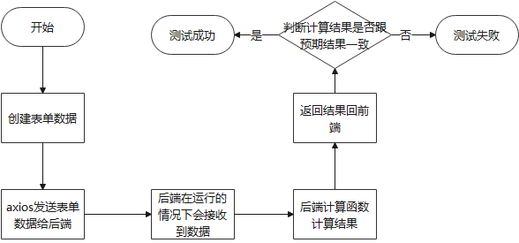

##### 测试代码

1. it('国内航班-2', () => {
2. const wrapper = mount(sw_1);
3. wrapper.vm.ruleForm.plane_type = "国内航班"
4. wrapper.vm.ruleForm.person_type = "p-1"
5. wrapper.vm.ruleForm.person_type = "v-1"
6. wrapper.vm.ruleForm.seat_type = "s-2"
7. wrapper.vm.ruleForm.region = 0
8. wrapper.vm.ruleForm.num = 1
9. wrapper.vm.ruleForm.spec1 = "普通行李"
10. wrapper.vm.ruleForm.spec2 = 0
11. wrapper.vm.ruleForm.length1 = 100
12. wrapper.vm.ruleForm.weight1 = 100
13. wrapper.vm.ruleForm.length2 = 0
14. wrapper.vm.ruleForm.weight2 = 0
15. wrapper.vm.ruleForm.price = 1000
16. let elementDOMWrapper11 = wrapper.find("[id='submit']");
17. elementDOMWrapper11.trigger("click")
18. setTimeout(function () {
19. console.log('waiting over.');
20. expect(wrapper.vm.result).to.be.equal(450);
21. console.log("hh:" + wrapper.vm.result);
22. }, 100)
23. });
24. if (valid) {
25. request.post("/1-sw", this.ruleForm).then(res => {
26. if (res.code === '0') {
27. this.$message({
28. type: "success",
29. message: "计算成功"
30. })
31. this.result = res.data.result
32. this.dialogVisible = true  *//开启弹窗显示数据*
33. } else {
34. this.$message({
35. type: "error",
36. message: res.msg
37. })
38. }
39. })
40. } else {
41. console.log('error submit!!')
42. return false
43. }

### 后端测试

#### 测试对象1-后端国内计算函数

##### 单元描述

这个单元测试主要是先从json文件中读取测试用例，然后将测试用例实例化之后，调用国内航班行李托运计算函数，然后将期望的值和返回的值进行比较，查看是否正确。

测试比较简单，难点在于测试用例的编写和json文件的转化，为了方便测试用例的生成，所以我配置了数据来存储计算过的用例，之后再将数据库的数据转化为json文件，最后导入进行测试。

##### 单元结构

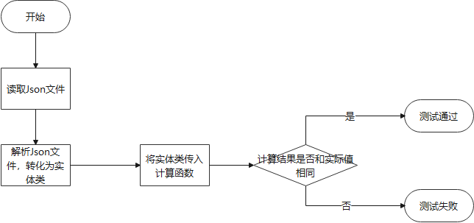

##### 测试代码

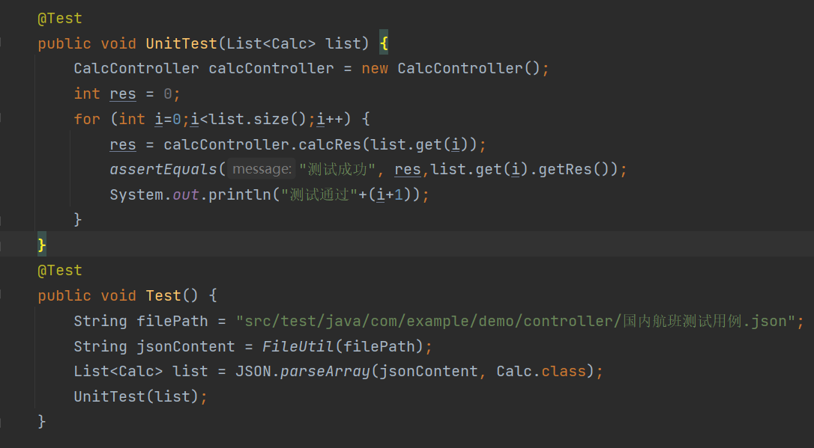

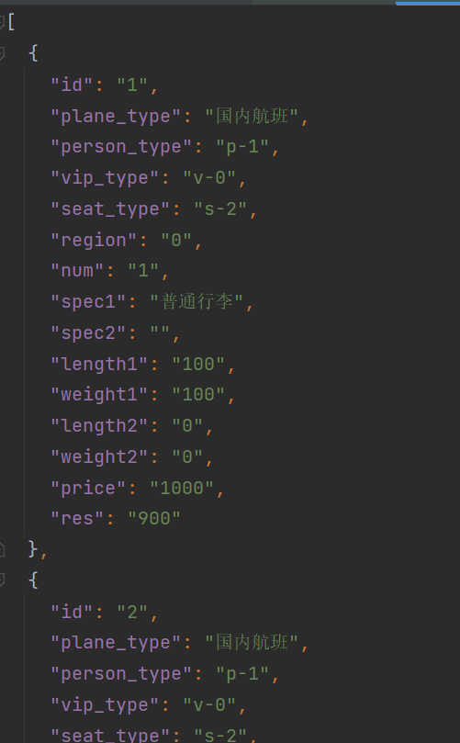

由于测试用例Json文件过于长，所以请见附件。

#### 测试对象2-后端国际计算函数

##### 单元描述

这个单元测试主要是先从json文件中读取测试用例，然后将测试用例实例化之后，调用国内航班行李托运计算函数，然后将期望的值和返回的值进行比较，查看是否正确。

测试比较简单，难点在于测试用例的编写和json文件的转化，为了方便测试用例的生成，所以我配置了数据来存储计算过的用例，之后再将数据库的数据转化为json文件，最后导入进行测试。

##### 单元结构



##### 测试代码

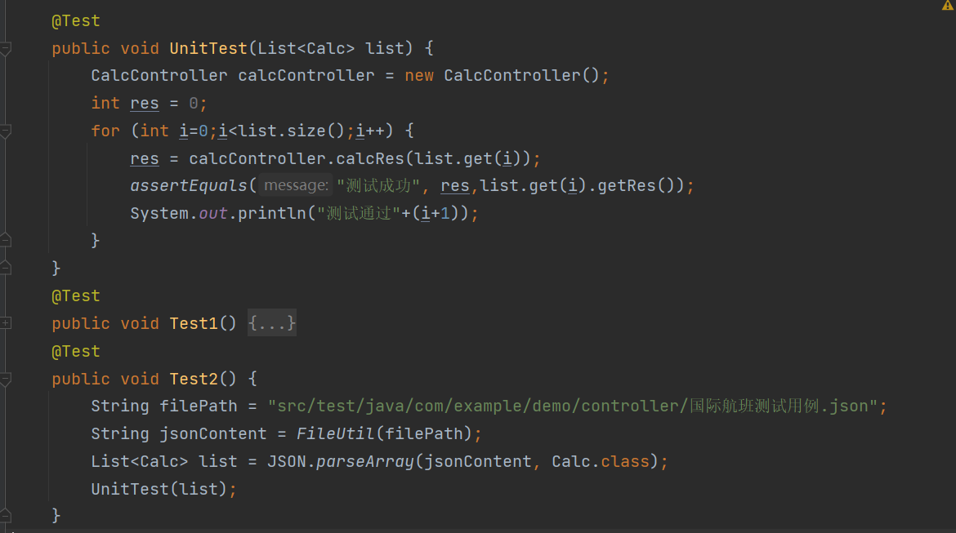

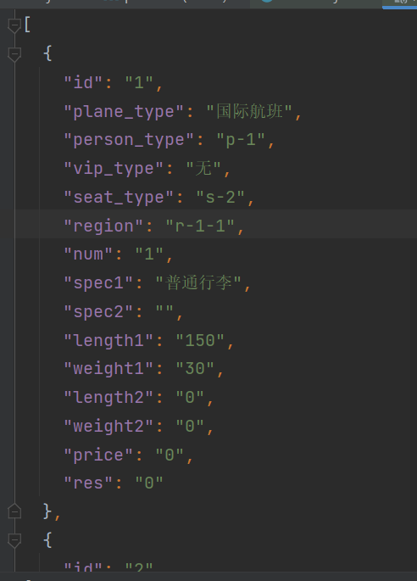

## 测试结果

### 前端测试结果

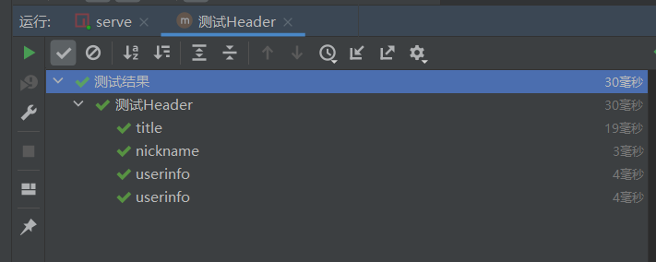

Header的ui测试通过；

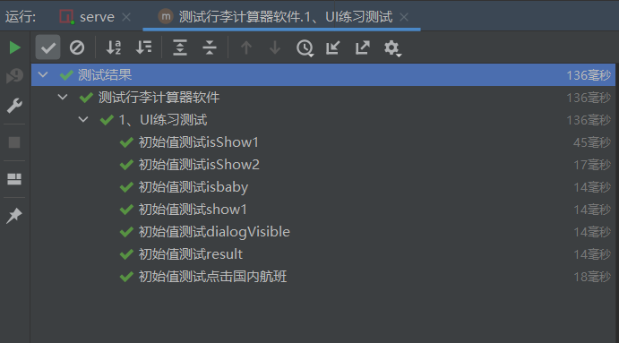

Conent的ui测试通过

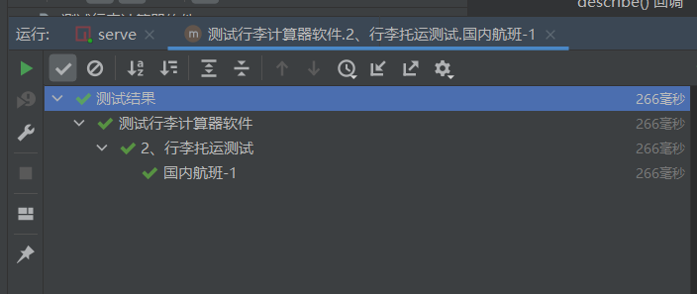

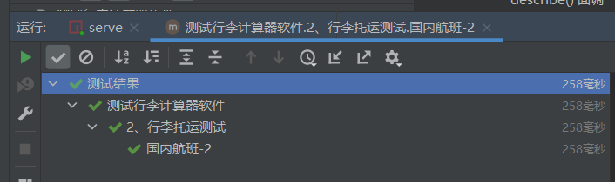

接口测试通过；

### 后端测试结果

国内测试用例通过：

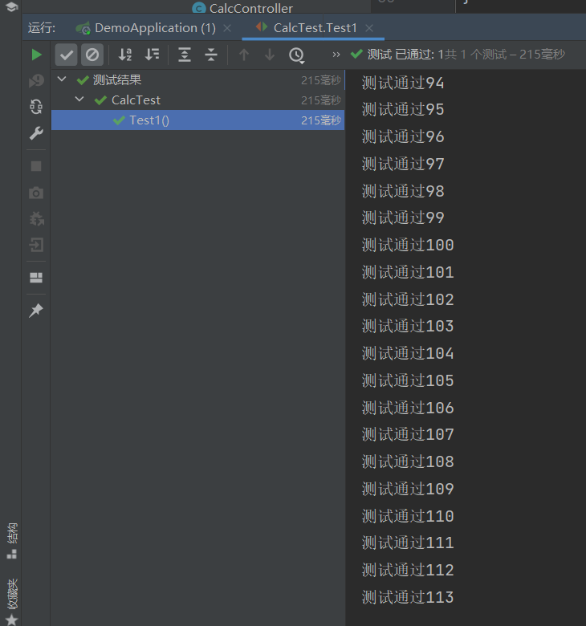

国际测试用例通过：

